

**Palestine Polytechnic University**

**College of IT and Computer Engineering**

**Department of Computer Engineering**

**Kinect based teleoperation of a humanoid robot**

**Supervisor**

Dr. Hashem Tamimi

**Team Members**

Mohannad Albustanji    181026

Eid Sonkrot                    217126

Huthaifa Rabae             237195

2023-2024

**Abstract**

Imitation between humans and humanoid robots is paramount for achieving a harmonious integration of technology into various aspects of daily life. The capability of humanoid robots to replicate human movements and actions closely aligns them with our physical expectations, facilitating smoother interactions and collaborations. This physical mimicry is particularly crucial in settings where robots and humans need to work together seamlessly, such as in manufacturing, rehabilitation, or assistance tasks. By emulating human motions, robots can more effectively assist or collaborate with humans, leading to enhanced efficiency and safety. Furthermore, in contexts where physical communication is fundamental, such as in caregiving or therapeutic roles, a humanoid robot's ability to imitate human gestures and movements becomes a powerful tool for establishing trust and connection. In essence, physical imitation serves as a bridge between the worlds of humans and robots, paving the way for a future where technology augments our capabilities and enriches our daily experiences.

Our project involves developing a system that captures motion data using a Microsoft Kinect sensor, processes this data with a microcontroller, and then translates it into machine code compatible with a humanoid robot environment. This setup aims to enable real-time imitation between humans and a Nao robot, a humanoid robot with 25 degrees of freedom, allowing it to closely mimic slow human movements. The Nao Robot serves as a dynamic platform for exploring humanoid robotics and AI capabilities.

Contents

Chapter 1: Introduction 7

1.1 Motivation and importance 7

1.2 Problem statement 7

1.3 Project Description 8

1.4 Aims and objectives 9

1.5 Report outline 10

Chapter 2: Background 11

2.1 Overview 11

2.2 Software Background 11

2.2.1 Programming Languages 12

2.2.2 Simulator 12

2.2.3 TensorFlow 12

2.3 Algorithms and theoretical background 13

2.3.1 Inverse Kinematics 13

2.3.2 Machine Learning 13

2.3.3 Deep Reinforcement learning 14

2.3.4 DDPG 15

2.4 Literature Review 17

2.4.1 Introduction 17

2.4.2 Studies 17

2.5 Hardware background 18

2.5.1 Humanoid robot (Nao) 18

2.5.2 Microsoft Kinect v2 20

2.5.3 Microcontroller (raspberry pi 4 model B) [24] 21

2.6 Conclusion 23

Chapter 3: System design 24

3.1 Preface 24

3.2 Requirements 24

3.3 Hardware design 25

3.3.1 System overview 25

3.3.2 Block diagram 26

3.3.3 System Pseudo Codes 27

3.4 System software design 29

3.4.1 Dataset 29

3.4.2 Neural Network 31

3.4.3 Inverse Kinematics 34

3.4.4 Why we choose DRL over kinematics techniques 35

3.5 Summary 35

Chapter 4: Implementation 36

4.1 Introduction 36

4.2 Hardware Setup 37

4.3 Software Configuration 38

4.3.1 Installing Necessary Software 39

4.3.2 Setting Up the Development Environment 41

4.3.3 System Software Interconnection Implementation 42

4.3.4 Inverse kinematics Implementation 45

4.3.5 Model Training Implementation 49

4.4 Challenges 51

Chapter 5: Testing and Results 53

5.1 Introduction 53

5.2 Hardware Testing 53

5.3 Software Testing 54

5.4 Results 55

5.4.1 Model training 55

5.4.2 Inverse Kinematics 56

Chapter 6: Conclusion and future work 57

6.1 Conclusion 57

6.2 Future Work 57

References 59

List of Figures

Figure 3.3 Stretches included in Dataset . . . . . . . . . . . . . . . . . . . . . . . . . . . . . . . . . . . . . . . . . . . 31

Figure 2.1 Deep Reinforcement Learning . . . . . . . . . . . . . . . . . . . . . . . . . . . . . . . . . . . . . . . . . . 14

Figure 2.2 Deep Neural network . . . . . . . . . . . . . . . . . . . . . . . . . . . . . . . . . . . . . . . . . . . . . . . . . 15

Figure 2.3 Deterministic Policy Gradient Algorithms . . . . . . . . . . . . . . . . . . . . . . . . . . . . . . . . .17

Figure 2.4 Nao Component . . . . . . . . . . . . . . . . . . . . . . . . . . . . . . . . . . . . . . . . . . . . . . . . . . . . . 21

Figure 2.5 Microsoft Kinect . . . . . . . . . . . . . . . . . . . . . . . . . . . . . . . . . . . . . . . . . . . . . . . . . . . . 22

Figure 2.6 Raspberry Pi 4 Components . . . . . . . . . . . . . . . . . . . . . . . . . . . . . . . . . . . . . . . . . . . . 24

Figure 2.7 Raspberry Pi 4 GPIO pinout . . . . . . . . . . . . . . . . . . . . . . . . . . . . . . . . . . . . . . . . . . . . 25

Figure 3.1 System Diagram . . . . . . . . . . . . . . . . . . . . . . . . . . . . . . . . . . . . . . . . . . . . . . . . . . . . . 27

Figure 3.2 System Block Diagram . . . . . . . . . . . . . . . . . . . . . . . . . . . . . . . . . . . . . . . . . . . . . . . . 28

Figure 3.4 Actor and Critic Networks . . . . . . . . . . . . . . . . . . . . . . . . . . . . . . . . . . . . . . . . . . . . . 34

Figure 4.1 Kinect Interconnection . . . . . . . . . . . . . . . . . . . . . . . . . . . . . . . . . . . . . . . . . . . . . . . . 38

Figure 4.2 How to get Nao’s IP . .. . . . . . . . . . . . . . . . . . . . . . . . . . . . . . . . . . . . . . . . . . . . . . . . . 39

Figure 4.3 Windows 10 Iot Installation . . . . . . . . . . . . . . . . . . . . . . . . . . . . . . . . . . . . . . . . . . . . 40

Figure 4.4 Webots Testing . . . . . . . . . . . . . . . .. . . . . . . . . . . . . . . . . . . . . . . . . . . . . . . . . . . . . . .41

Figure 4.5 Kinect Setup . . . . . . . . . . . . . . . . . . . . . . . . . . . . . . . . . . . . . . . . . . . . . . . . . . . . . . . . 42

Figure 4.6 RabbitMQ Installation . . . . . . . . . . . . . . . . . . . . . . . . . . . . . . . . . . . . . . . . . . . . . . . . .43

Figure 4.7 Body Basics-WPF. . . . . . . . . . . . . . . . . . . . . . . . . . . . . . . . . . . . . . . . . . . . . . . . . . . . 43

Figure 4.8 Kinect Skeleton. . . . . . . . . . . . . . . . . . . . . . . . . . . . . . . . . . . . . . . . . . . . . . . . . . . . . . 47

Figure 4.9 Training Approach. . . . . . . . . . . . . . . . . . . . . . . . . . . . . . . . . . . . . . . . . . . . . . . . . . . . 50

Figure 5.1 Kinect v2 glitch (example) . . . . . . . . . . . . . . . . . . . . . . . . . . . . . . . . . . . . . . . . . . . . . 55

Figure 5.2 Cherographe Testing. . . . . . . . . . . . . . . . . . . . . . . . . . . . . . . . . . . . . . . . . . . . . . . . . . .57

Figure 5.3 Project Testing. . . . . . . . . . . . . . . . . . . . . . . . . . . . . . . . . . . . . . . . . . . . . . . . . . . . . . . 58

List of Tables

Table 1.1 Project Schedule . . . . . . . . . . . . . . . . . . . . . . . . . . . . . . . . . . . . . . . . . . . . . . . . . . . . . . 10

Table 4.1 Equations . . . . . . . . . . . . . . . . . . . . . . . . . . . . . . . . . . . . . . . . . . . . . . . . . . . . . . . . . . . .47

# Chapter 1: Introduction

## 1.1 Motivation and importance

The development of motion detection mechanisms enhances the development of new applications for human motion analysis and reproduction. Kinect sensor and humanoid robot are two different technologies with various trends and applications. We plan to create a new trend with this combination, developing an interface whose applications will have future implications.

## 1.2 Problem statement

Teleoperation of robots has become increasingly important in a wide range of industries and applications, from manufacturing and logistics to medicine and disaster response. The ability to remotely control robots to perform complex tasks can significantly improve efficiency and safety, particularly in hazardous or hard-to-reach environments.

However, accurately replicating human movements in real time can be a significant challenge for teleoperation systems. Human movements are complex and varied, and can be difficult to capture and reproduce in a way that is both accurate and responsive.

The goal of this project is to develop a teleoperation system that can accurately replicate complex human movements using a Kinect sensor and a Nao robot. The system will use machine learning techniques, including deep learning and reinforcement learning, to enable the robot to learn and replicate movements in real time.

Specifically, the system will use the Kinect sensor to capture 3D skeletal joint data in real time, which will be processed and used to control the movements of the Nao robot.

The machine learning algorithms will enable the robot to learn and replicate a wide range of movements, from simple gestures to more complex movements such as dance routines or surgical procedures.

The success of this project will enable the development of more efficient teleoperation systems for a variety of applications.

The ability to accurately replicate complex human movements in real time has the potential to significantly improve efficiency and safety in industries ranging from manufacturing and logistics to medicine and disaster response, and could have a profound impact on how robots are used in the future.

## 1.3 Project Description

The proposed system is designed to capture human motion data using a Kinect sensor and reproduce the movements in real-time using NAO robots. The system consists of three main components: the Kinect sensor, the microcontroller, and the NAO robot.

The Kinect sensor is a device that uses depth sensing technology to capture detailed motion data from a human performer. IR wave is emitted and its reflection is detected by the Kinect sensor from the environment [7], creating a 3D model of the performer's body. The sensor can track the position and orientation of the performer's joints, providing information about their movements.

The motion data captured by the Kinect sensor is transmitted to a microcontroller using a wired USB 3 cable. The microcontroller processes the data and sends it to the NAO robot, which is equipped with software that can analyze and reproduce the movements in real-time. The NAO robot is a humanoid robot developed by Softbank Robotics, designed to mimic human movements and interact with humans in a natural way. The robot is equipped with sensors and cameras that allow it to perceive its environment and respond to external stimuli.

The system can be used to capture a wide range of human movements, from simple gestures to complex dance routines. The NAO robot can reproduce the movements in real-time, allowing for immediate feedback and analysis [8].

The system can be used in a variety of applications, such as in physical therapy, sports training, and entertainment. The system can also be used to analyze the movements of individuals with disabilities, providing valuable information for rehabilitation and therapy.

Overall, the proposed system offers a cost-effective and efficient solution for capturing and analyzing human motion data. The combination of the Kinect sensor and the NAO robot provides a flexible and versatile platform for real-time reproduction of the motion data, with potential applications in a wide range of industries.

The machine learning algorithms used in the software allow for efficient analysis of the motion data, making the system an ideal tool for a variety of applications.

## 1.4 Aims and objectives

1. To deliver an affordable and efficient method for capturing and analyzing human motion data utilizing the Kinect sensor and NAO robot.
2. To foster the development of innovative applications in areas like physical therapy, sports training, and entertainment, focusing on human motion analysis and replication.
3. To bolster research in human-computer interaction by offering a dynamic and adaptable platform to explore interactions between humans and robots.
4. To enhance the application of robotics and AI in educational settings, providing practical learning opportunities for students and researchers in robotics and computer science.
5. To serve as an alternative to existing, more costly and labor-intensive technologies like traditional motion capture systems.

## 

## 1.5 Report outline

Week 1 start from 1 Sep

|  |  |  |  |  |  |  |  |  |  |  |  |
| --- | --- | --- | --- | --- | --- | --- | --- | --- | --- | --- | --- |
| Task \ Week | 1 | 2 | 3 | 4 | 5 | 6 | 7 | 8 | 9 | 10 | 11 |
| QA plan |  |  |  |  |  |  |  |  |  |  |  |
| Project plan |  |  |  |  |  |  |  |  |  |  |  |
| Plan review |  |  |  |  |  |  |  |  |  |  |  |
| Project analysis |  |  |  |  |  |  |  |  |  |  |  |
| Requirements |  |  |  |  |  |  |  |  |  |  |  |
| Project design & implementation |  |  |  |  |  |  |  |  |  |  |  |

Table 1.1 Project Schedule

# Chapter 2: Background

## 2.1 Overview

This chapter serves as an introductory overview of the key components and theoretical underpinnings that form the basis of our project. We will begin by discussing the theoretical background, with a particular focus on the latest developments in deep learning, machine learning, and traditional robotics, and how these fields relate to teleoperation. Our project relies heavily on these fields, and a thorough understanding of their principles is necessary for its successful implementation. Specifically, we will explore the most up-to-date algorithms and techniques used in these fields, which are crucial for enabling our teleoperation system to operate with high accuracy and complexity.

This chapter aims to provide readers with a foundational understanding of the key concepts and methods used in our project, laying the groundwork for a more detailed exploration of our system in subsequent chapters.

## 2.2 Software Background

The software component of our project plays a crucial role in processing the data from the Kinect sensor and controlling the Nao robot's movements. This section provides an overview of the algorithms, programming languages and frameworks used in the development of our software.

### 2.2.1 Programming Languages

For our project, we have decided to use Python as the primary programming language (for Inverse Kinematics and deep learning). Python is a popular language for scientific computing, data analysis, and artificial intelligence due to its simplicity, readability, and vast library support. Also, we have decided to use C# to read depth data form Kinect sensor.

### 2.2.2 Simulator

Webots is a robotics simulation software widely used in both academia and industry for robotics and machine learning applications. It offers a virtual environment where developers can design, program, and test their robot models before implementing them in real life [10].

Key features of Webots include:

* + - 1. Realistic Physics Simulation: Webots provides a realistic simulation of robot mechanics and environmental interactions, essential for accurate testing of control algorithms.
      2. Versatile Environment Customization: Users can design a variety of custom environments in Webots, allowing for extensive testing of robot performance under different conditions.
      3. Compatibility with Machine Learning Frameworks: Webots supports integration with popular machine learning platforms like TensorFlow, enabling the development and testing of advanced robot control algorithms.
      4. Open-Source Availability: As an open-source platform, Webots allows for code modifications and adaptations to fit specific project needs.

### 2.2.3 TensorFlow

TensorFlow is an open-source machine learning framework developed by Google. It allows developers to create and train machine learning models using a wide range of tools and techniques. TensorFlow is particularly well-suited for deep learning applications, such as neural networks with many layers [9].

Some key features of TensorFlow include:

* + - 1. High performance: TensorFlow is optimized to take full advantage of modern hardware, including GPUs and TPUs.
      2. Flexibility: TensorFlow supports a wide range of model architectures, including convolutional neural networks, recurrent neural networks, and more.
      3. Large community: TensorFlow has a large and active community of developers, which means there are many resources available for learning and getting help.
      4. Easy deployment: TensorFlow models can be easily deployed to a wide range of platforms, including mobile devices, the web, and the cloud.

## 2.3 Algorithms and theoretical background

### 2.3.1 Inverse Kinematics

Inverse kinematics refers to the mathematical process of determining the joint parameters that will position a humanoid robot's limbs in a desired configuration. In the context of both humans and humanoid robots, inverse kinematics is crucial for planning and controlling movements. It involves calculating the joint angles or positions required to achieve a specific end-effector position or orientation.

### 2.3.2 Machine Learning

Machine learning is a subfield of artificial intelligence that focuses on developing algorithms and models capable of learning from data and making predictions or decisions. It involves the design and development of mathematical and statistical models that can automatically improve and adapt through experience [11].

Machine learning techniques enable computers to learn patterns, extract insights, and make predictions or take actions without explicit programming. It finds applications in various domains, including image and speech recognition, natural language processing, recommender systems, and autonomous decision-making.

Machine learning algorithms utilize data to learn from examples, identify patterns, and generalize to new, unseen data, enabling automated data-driven solutions to complex problems.

### 2.3.3 Deep Reinforcement learning

Deep reinforcement learning (DRL) is a type of machine learning technique that enables agents to learn how to make decisions in complex environments by trial and error. It combines deep learning and reinforcement learning, two powerful techniques that have been successful in solving a variety of machine learning problems [12].

Reinforcement learning involves training an agent to make decisions based on feedback received from its environment. The agent learns to take actions that maximize a reward signal, which is a scalar value that indicates how well the agent is performing its task.

The goal of the agent is to learn a policy, which is a mapping from states to actions that maximizes the expected cumulative reward.

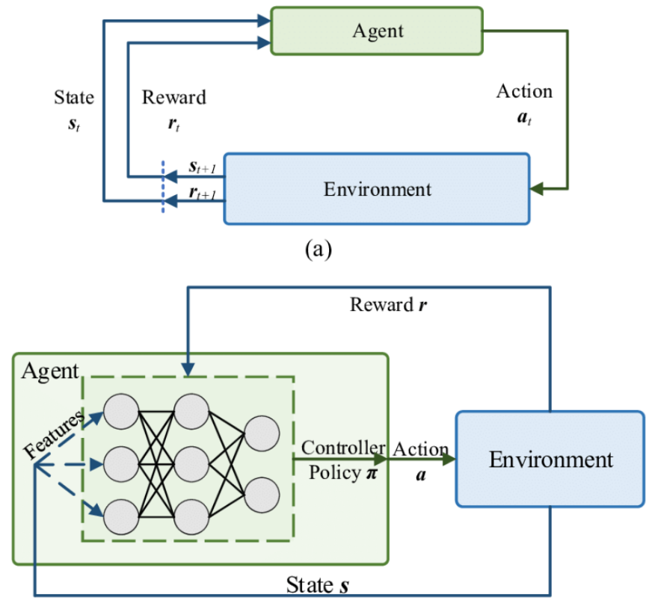

Figure 2.1 Deep Reinforcement Learning [16].

DRL combines two techniques by using deep neural networks to approximate the value function or policy of the agent.

The deep neural networks are used to represent the state-action value function, which is used to select the best action in each state, or the policy function, which is used to directly map states to actions.

This enables agents to learn from high-dimensional inputs, such as images and sensor readings, and make decisions in complex and dynamic environments [17].

.

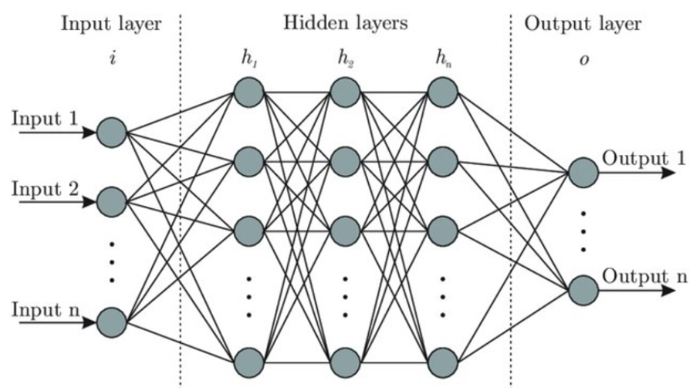

Figure 2.2 Deep Neural network [13].

### 2.3.4 DDPG

Deep Deterministic Policy Gradient (DDPG) is a reinforcement learning algorithm that combines the ideas of Deep Learning and Policy Gradients with Q-Learning. The goal of the algorithm is to learn a deterministic policy, which maps states to actions directly, as opposed to a stochastic policy, which maps states to probability distributions over actions [14].

DDPG is based on the Actor-Critic method, which uses two neural networks: an Actor network and a Critic network.

The Actor network is responsible for learning the policy, i.e., mapping the state to the action, while the Critic network is responsible for learning the Q-value of the state-action pairs.

The Q-value represents the expected discounted future reward of taking a specific action from the current state.

DDPG has been shown to be effective in solving high-dimensional continuous control problems, such as robotic arm control, locomotion, and manipulation tasks.

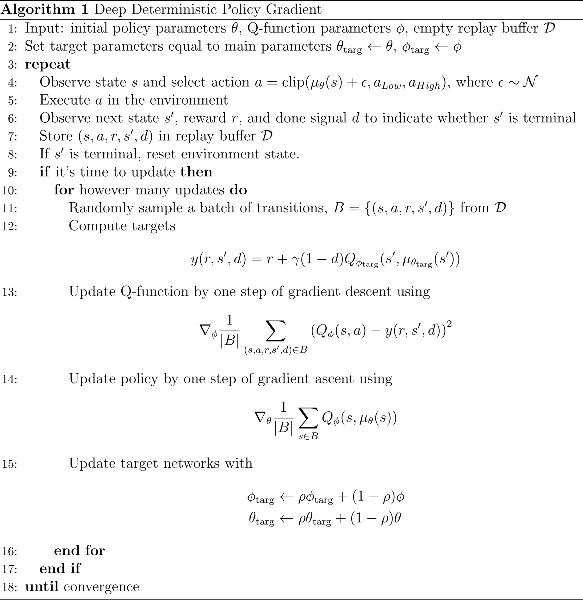

Figure 2.3 Deterministic Policy Gradient Algorithms [15].

## 2.4 Literature Review

### 2.4.1 Introduction

Human body tracking has become a critical aspect of many applications, including gaming, sports analysis, and medical rehabilitation.

The use of robotics in such applications has also grown in recent years, with robots being used to assist in geriatric physiotherapy rehabilitation, imitating human actions for autism treatment, and lifting objects.

The aim of this literature review is to explore studies that have utilized the Kinect sensor and the NAO robot to track human body movements.

### 2.4.2 Studies

**Kinect Controlled NAO Robot for Telerehabilitation:** This study showcases the Kinect V2 sensor's capability in marker less vision-based motion tracking, using modified Denavit-Hartenberg convention for kinematic modeling of the human upper arm to mimic therapist movements [1].

**Lower-body Control of Humanoid Robot NAO via Kinect:** Proposes a joint angle-based control scheme, emphasizing Kinect's potential in capturing and translating lower-body movements to robotic actions [3].

**NAO Robot Teleoperation with Human Motion Recognition:** Introduces a Kinect-based teleoperation framework using Hidden Markov Model (HMM), highlighting the Kinect v2.0's effectiveness in human motion capture [6].

**Robot Sensor System for Supervised Rehabilitation:** Demonstrates the effective use of NAO and Kinect sensors in supervising rehabilitation exercises, particularly for shoulder and elbow joints [4].

**Motion Recognition using Deep Convolutional Neural Network for Kinect-based NAO Teleoperation:** Presents a motion recognition framework enhancing the NAO robot's ability to imitate human behavior, using an adaptive balancing technique and a 7-layer one-dimensional convolutional neural network [5].

**Dynamic-goal Deep Reinforcement Learning for Industrial Robot Telemanipulation:** The paper by Zhang et al. provides foundational knowledge for robot movement control using Kinect. inspires the use of deep reinforcement learning for human motion data mapping to robot trajectories [2].

These works form a crucial basis for a project leveraging deep reinforcement learning with Nao robots and Kinect sensors for applications in education, entertainment, and healthcare.

## 2.5 Hardware background

### 2.5.1 Humanoid robot (Nao)

* NAO is a versatile humanoid robot created by SoftBank Robotics [19].
* NAO has become a benchmark in the world of research and education, as well as in healthcare, retail, and tourism.
* With his advanced sensors and interactive capabilities, NAO can adapt to any environment and interact with people in a natural way.
* He is fully programmable and customizable, making it possible to create application solutions that enable him to perform tasks in different areas based on all of his capabilities, including dialogue and motion [19].

#### 2.5.1.1 Nao hardware specifications [19]:

1. Dimensions:
   * Height: 58 cm (22.8 inches)
   * Width: 27 cm (10.6 inches)
   * Depth: 22 cm (8.7 inches)
   * Weight: Approximately 4.3 kg (9.5 lbs)
2. Processing Unit:
   * Intel Atom Z530 Processor (1.6 GHz)
3. Memory:
   * 1 GB DDR2 RAM
4. Storage:
   * 2 GB Flash Memory
5. Sensors:
   * Two HD cameras (resolution: 1280x960 pixels)
   * Ultrasonic sensors for obstacle detection
   * Touch sensors on the head, hands, and feet
   * Inertial measurement unit (accelerometer and gyro-meter)
   * 4 Microphones for sound localization and voice recognition
6. Connectivity:
   * Wi-Fi (IEEE 802.11 b/g)
   * Ethernet port (10/100 Mbps)
   * USB 2.0 port
7. Power:
   * Battery: Lithium-ion battery
   * Battery capacity: 4800 mAh with approximately 60-90 minutes of continuous operation
   * Charging Time: Approximately 90 minutes
8. Operating System:
   * Aldebaran NAOqi OS (based on Linux)
9. Actuators:
   * 25 Degrees of Freedom (DOFs) for joint movement
   * Electric motors for actuation, including head, arms, hands, legs, and feet
10. Additional Features:
    * Text-to-speech synthesis
    * Voice and sound recognition
    * LED lights for visual feedback
    * Speaker for audio output

#### 2.5.1.2 Nao Components:

Figure 2.4 Nao Component [20]

### 2.5.2 Microsoft Kinect v2

Kinect v2 is a depth-sensing camera developed by Microsoft, primarily used for capturing skeletal joint data and depth information. It offers an enhanced user experience in motion tracking, gesture recognition, and 3D depth sensing. The operation principle of Kinect v2 is ToF with modulation up to 130MHz, acquisition rate = 30Hz. In this section, we will explore the main components that Kinect work with it [22][23].

1. **Depth Sensing:** Kinect v2 utilizes an infrared depth sensor that captures the depth information of the surrounding environment.

It can measure the distance between the sensor and objects in its field of view. It provides a depth resolution of up to 512x424 pixels, FOV (H=70.6o x V=60o), depth range (0.5-4.5) m, with ability to capture depth information with sub-millimeter precision [22].

1. **Color Camera:** In addition to depth sensing, Kinect v2 is equipped with a high-definition RGB color camera. It captures color images with a resolution of 1920x1080 pixels, FOV (H=84.1o x V=53.8o), enhancing the visual fidelity of the captured data [23].
2. I**nfrared Camera:** Kinect v2 includes an infrared (IR) camera that works in tandem with the depth sensor. It measures the distance between the camera and objects by projecting IR patterns and analyzing the distortion caused by their interaction with the environment [22].
3. **Microphone Array:** The device incorporates a built-in microphone array that enables voice recognition and audio processing. This feature facilitates natural language interaction and voice commands [23].

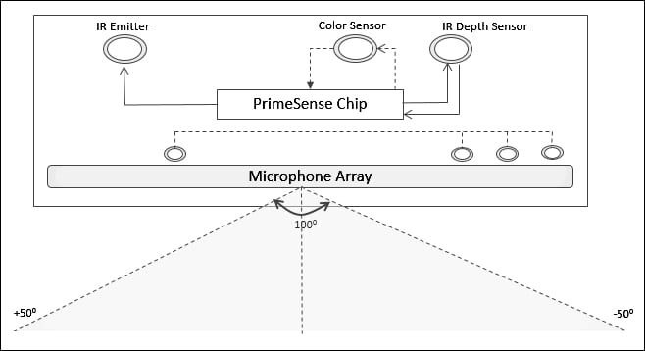

Figure 2.5 Microsoft Kinect [21]

### 2.5.3 Microcontroller (raspberry pi 4 model B) [24]

The Raspberry Pi 4 Model B is a versatile single-board computer that was released by the Raspberry Pi Foundation in June 2019. It is the fourth generation of the Raspberry Pi series, following the Raspberry Pi 3 Model B+. The Raspberry Pi 4 Model B offers significant improvements in terms of processing power, memory, connectivity, and multimedia capabilities compared to its predecessors [24].

1. Processor:
   * Broadcom BCM2711 quad-core Cortex-A72 (ARMv8) 64-bit SoC
   * Clock speed: 1.5 GHz
2. Memory:
   * Options: 4GB LPDDR4 SDRAM
3. Storage:
   * MicroSD card slot for the operating system and storage
4. GPU:
   * VideoCore VI
5. Connectivity:
   * 2 × USB 3.0 ports
   * 2 × USB 2.0 ports
   * Gigabit Ethernet port (RJ45)
   * 2.4 GHz and 5 GHz IEEE 802.11b/g/n/ac wireless LAN
   * Bluetooth 5.0
6. Display:
   * Two micro-HDMI ports
7. Audio:
   * 3.5mm audio jack
   * HDMI audio output
8. Camera Interface:
   * MIPI CSI camera port for connecting a Raspberry Pi camera module
9. Display Interface:
   * MIPI DSI display port for connecting a Raspberry Pi touch display
10. GPIO:
    * 40-pin GPIO header (compatible with previous Raspberry Pi models)
11. Power:
    * USB-C power supply connector (5V DC)
12. Operating System
    * Officially supported operating systems include various Linux distributions (Raspberry Pi OS, Ubuntu, etc.) and Windows 10 IoT Core.

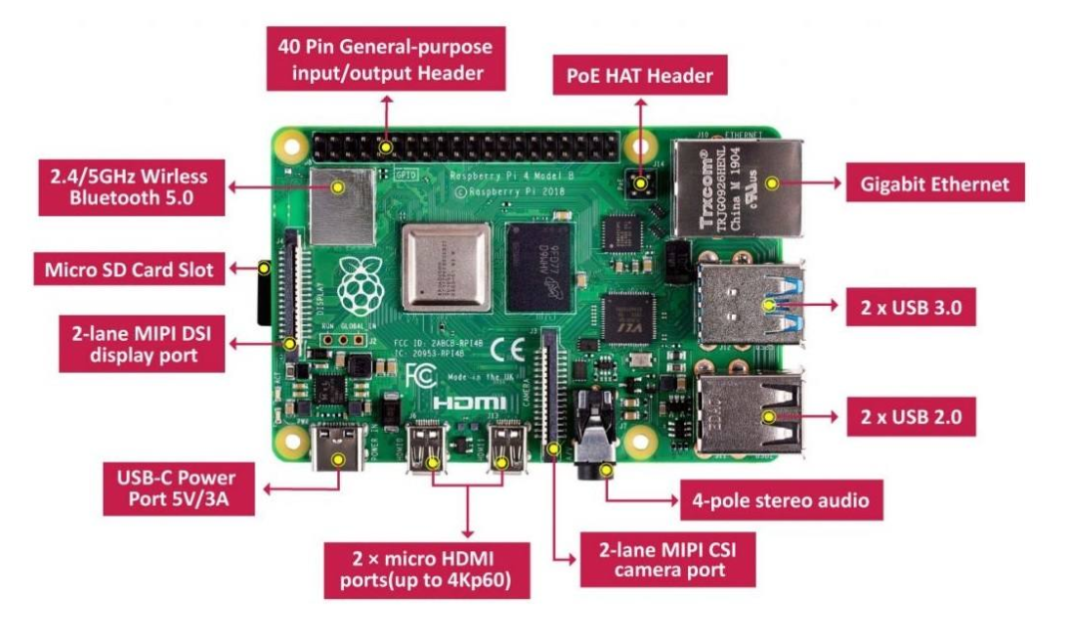

Figure 2.6 Raspberry Pi 4 Model B Components [25]

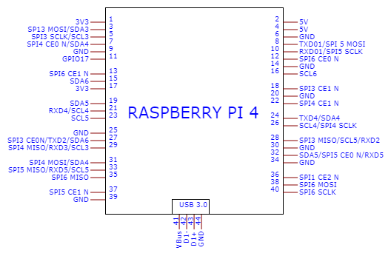

Figure 2.7 Raspberry Pi 4 GPIO pinout [26]

## 2.6 Conclusion

The "Kinect based teleoperation of a humanoid robot" project is designed to offer an affordable and effective method for capturing and analyzing human motion data. This project is set to enable the real-time replication of human movements with notable accuracy and fidelity. Additionally, it will play a significant role in the advancement of assistive technologies for people with disabilities by offering real-time analysis and reproduction of their movements. This project is also aimed at enhancing research in human-computer interaction by providing a versatile platform to explore interactions between humans and robots. It promises to encourage the integration of robotics and artificial intelligence in educational settings. Furthermore, this initiative is expected to serve as a cost-effective alternative to more traditional and expensive motion capture technologies. It will also pave the way for the development of new applications in various domains, including physical therapy, sports training, and entertainment, and will bring forth novel industry applications in these areas, as well as in the integration of realistic characters in video games.

# Chapter 3: System design

## 3.1 Preface

In this chapter, we will present the design of a system that uses a Nao 6 robot and Kinect v2 sensor to capture and mimic the movements of a human. The system is designed to enable the robot to learn and replicate the movements of a human, allowing it to perform tasks that require fine motor skills and dexterity. The chapter will cover the main features and components of the system, including the hardware and software components, the communication between the robot and the sensor, and the algorithms used for movement mapping and deep reinforcement learning. We will also discuss the challenges and limitations of the system, as well as future directions for improving its performance and expanding its capabilities.

## 3.2 Requirements

1. The system should enable human teleoperation of the Nao robot's motion using the Kinect sensor as an input device.
2. The system should track the user's movements and translate them into corresponding movements for the Nao robot within his possibilities and 25 degrees of freedom.
3. The system should perform complex movements and actions with accuracy in terms of centimeters.
4. The system should incorporate closed-loop control, which entails utilizing sensors to provide feedback.
5. The system shall be designed with modular architecture, ensuring that its components can be easily upgraded or replaced. It shall support integration with additional technologies and platforms through standardized interfaces and protocols. The system's performance shall maintain or improve with the addition of new modules or integration with different technologies.

## 3.3 Hardware design

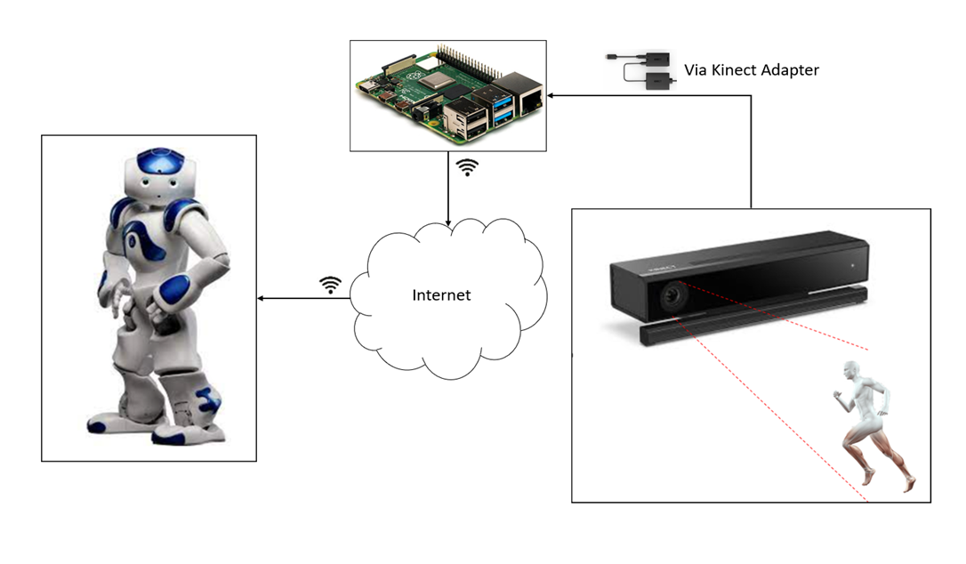 The Hardware design section provides an overview of the architecture and components of a robotic system designed to enable movement mimicking functionality.

Figure 3.1 System Diagram

### 3.3.1 System overview

The robotic system is designed to mimic human movements using deep reinforcement learning [27]. The system consists of various hardware and software components that enable the capturing and mapping of human movements to robot movements. The system architecture includes sensors to capture human movements, a controller to process the captured data, and actuators to control the robot's movements. The end goal of the system is to enable the robot to replicate human movements accurately in real-time.

### 

### 3.3.2 Block diagram

This figure shows the main parts of the system and how they interact.

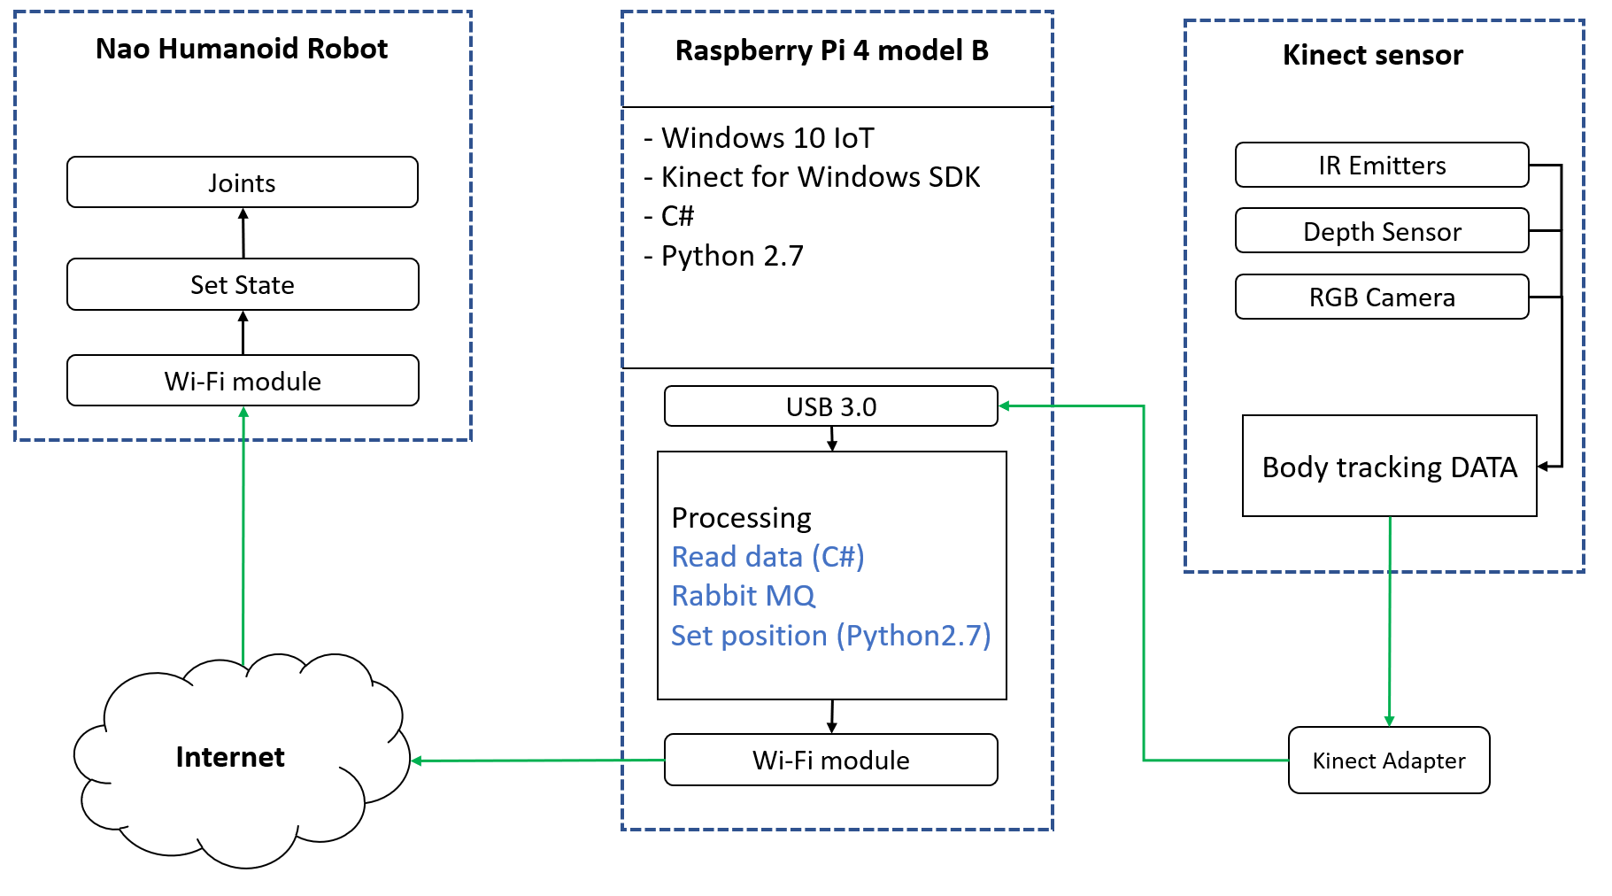

Figure 3.2 System Block Diagram

### 3.3.3 System Pseudo Codes

Algorithm 1 shown below runs on Microsoft Kinect V2. First, initialize Kinect, provide it a power supply, connect special adapter to it (USB B-type 🡪 USB 3.0). Second, from settings select a resolution: 512x424 px, frame rate: 30 fps and enable body tracking. Finally, inside loop, capture frames, read body tracking data, then send it to Raspberry Pi.

|  |  |
| --- | --- |
| Algorithm 1: Kinect sensor Pseudo code | |
| 1 | **Setup part:** |
| 2 | INITIALIZE Kinect |
| 3 | **CONNECT** Kinect to Kinect adapter |
| 4 | **SELECT** resolution, framerate |
| 5 | **ENABLE** Body Tracking |
| 6 | Loop part: |
| 7 | **WHILE** capturing frames: |
| 8 | **CAPTURE** frames (512x424@30fps) |
| 9 | **READ** Body tracking data |
| 10 | **MOVE** Body tracking data to Raspberry Pi |
| 11 | **ENDWHILE** |

Algorithm 2 runs on Nao humanoid robot. Initialize Nao and authenticate him to Raspberry Pi. In loop part, while raspberry pi sends Instructions; receive Instructions from Raspberry Pi, compile and regenerate executable Instructions for Nao. Finally Execute Instructions for Nao to change his state as like as possible to human state.

|  |  |
| --- | --- |
| Algorithm 2: Nao robot Pseudo code | |
| 1 | Setup part: |
| 2 | **INITIALIZE** Nao robot |
| 3 | **AUTHENTICATE** Raspberry Pi |
| 4 | Loop part: |
| 5 | **WHILE** raspberry pi sends Instructions: |
| 6 | **RECV** Instructions from Raspberry Pi using Wi-Fi |
| 8 | **SET** position |
| 9 | **ENDWHILE** |

Algorithm 3 runs on Raspberry Pi 4 model B. At the beginning initialize Raspberry Pi, install Ubuntu, setup pyKinect2 library, setup python. Next step, add DDPG library to python and connect the Kinect adapter to USB 3.0 port on Raspberry Pi. Inside loop; receive body tracking data from Kinect via Kinect adapter, execute Deep Deterministic Policy Gradient (DDPG) algorithm to get prediction to next state, then convert the next state data set into python Instructions for Nao to change his state and send instructions to Nao using Wi-Fi.

|  |  |
| --- | --- |
| Algorithm 3: Raspberry Pi 4 model B Pseudo code | |
| 1 | Setup part: |
| 2 | **INITIALIZE** Raspberry pi |
| 3 | **SETUP** windows 10 |
| 4 | **SETUP** Kinect for Windows SDK |
| 5 | **SETUP** Python, C# |
| 6 | **IMPORT** numpy, pika, tensorflow, naoqi, Microsoft.Kinect(C#) |
| 7 | **CONNECT** Kinect adapter to USB 3.0 port in Raspberry pi |
| 8 | Loop part: |
| 9 | **WHILE** data != NULL: |
| 10 | **RECEIVE** Body Tracking DATA from Kinect via Kinect adapter |
| 11 | **CONVERT** 3D depth data into motor angles |
| 12 | **SEND** Instructions to Nao using Wi-Fi |
| 13 | **ENDWHILE** |

## 3.4 System software design

The system software design section provides an overview of the architecture and design principles underlying the development of our project. This section focuses on the high-level structure of the software system and how its various components interact with each other. By presenting the system software design upfront, we aim to provide readers with a clear understanding of the overall system organization and the rationale behind our design choices. This preface sets the stage for the subsequent discussions on training, execution, and other aspects of the project, enabling readers to navigate through the technical details with a solid grasp of the system's architecture and design principles.

### 3.4.1 Dataset

#### 3.4.1.1 Dataset Collection and Specifications

The primary dataset for training the AI model, comprising data from 127 volunteers with varying heights and body sizes, was captured using the Kinect sensor [28]. To enrich the dataset, particularly for leg movement analysis, an additional dataset which focuses on lower-body motion, has been integrated. This dataset from provides extensive and specialized leg movement data, enhancing the model's ability to accurately recognize and replicate lower-body actions [29].

#### 3.4.1.2 Pose Variations and Movements

Each volunteer performed a series of eight predefined positions or poses, including [28]:

1. Y Stretch
2. SOMU Stretch
3. MERMAID Stretch
4. SEATED Stretch
5. TOWEL Stretch
6. 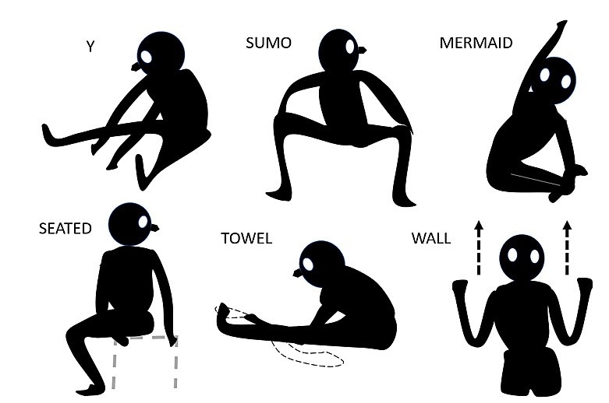WALL Stretch

Figure 3.3 Strertches included in Dataset [28]

In addition to these predefined poses, the volunteers also performed a range of movements that fall under the same position category. This inclusion of movements allows for capturing more dynamic and natural pose variations.

#### 3.4.1.3 Data Collection Process [28]

For each volunteer, a total of 240 frames were recorded. Each frame consists of the 25 joint camera coordinates in X, Y, and Z dimensions.

This joint coordinate provides a comprehensive representation of the human body's pose and

movement.

#### 3.4.1.4 Training and Testing Data Split

The recorded dataset consists of a total of 30,480 frames. To ensure an effective training process, the dataset was split into two subsets: a training dataset and a testing dataset.

Approximately 72% of the frames, amounting to 21,926 frames, were used as the training data. This larger portion of the dataset is dedicated to training the AI model to learn and imitate the desired poses accurately [28].

The remaining 28% of the frames, approximately 8,554 frames, were reserved for testing the trained model's performance. This testing dataset serves as an independent evaluation set to assess the AI model's ability to generalize and reproduce the poses accurately [28].

### 3.4.2 Neural Network

#### 3.4.2.1 The actor and critic networks

The actor and critic networks are trained simultaneously, but they serve different purposes.

**Actor Network**: The actor network is responsible for learning and generating the optimal probability for the desired movements [18]. It takes the joint positions and movements as input and outputs the policy that determines the next action to be taken by the Nao robot.

**Critic Network**: The critic network evaluates the actions taken by the actor network and estimates the corresponding Q-value. The Q-value represents the expected cumulative reward associated with a particular action given the current state of the environment. The critic network helps guide the actor network by providing feedback on the quality of the chosen actions [18].

The neural networks, along with the DDPG algorithm, form an iterative process. During training, the networks interact with the environment (represented by the Nao robot) by receiving sensory input from the Kinect sensor and taking actions based on the learned policy. The resulting feedback and rewards from the environment are used to update the networks' weights and improve their performance over time [31].

By employing this flow of steps and the interaction between the actor and critic networks with the environment, we can train the neural network to learn and generate human-like movements based on the provided dataset and the reinforcement learning framework.

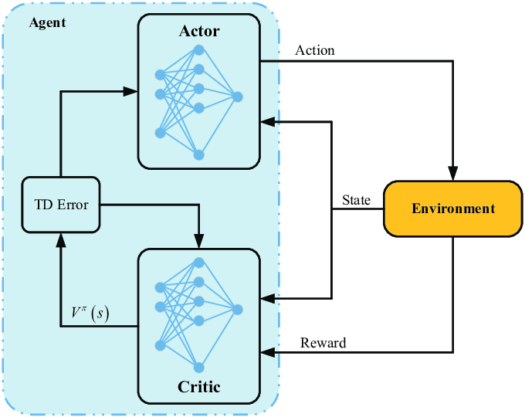

Figure 3.4 Actor and Critic Networks (RNN) [31]

#### 3.4.2.2 Reward function

The reward function in our project plays a crucial role in shaping the learning process of the agent and guiding it towards the desired behavior. It quantifies the performance of the agent based on its actions and the current state of the environment. The goal is to design a reward function that encourages the agent to learn the desired movements and behaviors for the Nao robot.

In our project, we define the reward function to incorporate the concept of distance between the goal position and the current position of the Nao robot's joints in the virtual environment. We calculate the Euclidean distance between the goal position and the current position, and use it as a basis for assigning rewards.

The reward function can be defined as follows [15]:

$$reward= e^{-α⋅distance}$$

In this equation, **α** is a scaling factor that determines the influence of the distance on the reward. A higher **α** value results in a steeper reward decay as the distance increases, while a lower **α** value makes the reward decay more gradual. By using the exponential function, we ensure that the reward decreases exponentially as the distance between the goal and the current position increases.

The purpose of this reward function is to encourage the Nao robot to move closer to the goal position, as it will receive higher rewards for smaller distances. This incentivizes the agent to learn movements that bring it closer to the desired goal and helps in training it to mimic human-like movements.

#### 3.4.2.3 Pseudocode for training process

|  |  |
| --- | --- |
| Training process Pseudocode | |
| 1 | Setup part: |
| 2 | $Initialize actor_network with random weight$ |
| 3 | $Initialize critic_network with random weights$ |
| 4 | $Initialize target_networks for actor and critic (same as main networks)$ |
| 5 | $Initialize replay_buffer for storing experience tuples$ |
| 6 | $Initialize virtual_environment with initial_state$ |
| 7 | $Initialize dataset with reading Kinect_sensore_value$ |
| 8 | Loop part: |
| 9 | $for dataframe in dataset:$ |
| 10 | $virtual_environment.reset()$ $//Reset virtual environment to initial state$ |
| 11 | $current_state= virtual_environment.joint(┤)$ $// Reading value of joint$ |
| 12 | $current_goal= dataframe$ |
| 13 | $for timestep in range(maximum_timesteps):$ |
| 14 | $action = actor_network.get_action(current_state,noise)$ $// generate action$ |
| 15 | $virtual_environment.update(action) // apply action on virtual environment$ |
| 16 | $next_state= virtual_environment.joint(┤)$ |
| 17 | $distance = calculate_distance(next_state, current_goal )$ |
| 18 | reward = $exp⁡(-alpha * distance)$ |
| 19 | $replay_buffer.append(tuple (current state, action, reward, next state))$ |
| 20 | $replay= replay_buffer.Sample_batch(┤)$ |
| 21 | $Q_targets= calculate_(q_targets(replay) )$ |
| 22 | $critic_loss= calculate_(critic_loss(Q_predicted, Q_targets ) )$ |
| 23 | $update_(critic_network(critic_loss ) )$ |
| 24 | $actor_loss= calculate_(actor_loss(actor_gradients ) )$ |
| 25 | $update_(actor_network(actor_loss ) )$ |
| 26 | $Save trained actor and critic networks$ |

### 3.4.3 Inverse Kinematics

**Definition**

Finds the joint angles or positions needed to achieve a specific end-effector pose.

**Complexity**

Inverse kinematics problems can be complex, especially for robots with multiple joints and degrees of freedom. In this project inverse kinematics for the Nao robot involves handling the complexity of multiple joints and degrees of freedom (25 degree of freedom).

**Challenges**

* **Singularities**: Consider how to handle singularities and multiple solutions, especially when mapping human movements to the robot's joint space.
* **Real-world constrains**: Account for physical limitations of the Nao robot, such as joint limits and mechanical restrictions.

### 3.4.4 Why we choose DRL over kinematics techniques

We chose Deep Reinforcement Learning (DRL) over inverse kinematics techniques for our project due to its ability to handle complex and dynamic environments. Inverse kinematics techniques typically rely on solving mathematical equations to determine joint angles that can achieve a desired end-effector position. While these techniques work well for simple and static scenarios, they struggle with more complex movements and changing environments. DRL, on the other hand, allows an agent to learn optimal policies through interactions with the environment, without requiring explicit mathematical models or equations.

With DRL, we can train an artificial agent, such as a neural network, to mimic human-like movements by observing and imitating the data collected from the Kinect sensor. This approach offers greater flexibility and adaptability, as the agent can learn from diverse and dynamic situations, including variations in joint positions, body sizes, and movements.

DRL also enables the agent to generalize its learned behaviors to new scenarios, making it suitable for real-world applications where the environment may be unpredictable or subject to changes.

Additionally, DRL allows for the exploration of more complex movements beyond what can be achieved through inverse kinematics. By combining reinforcement learning algorithms with deep neural networks, the agent can learn intricate patterns and coordination of joints, enabling it to perform not only predefined poses but also more nuanced movements, such as finger movements or fine-grained control.

Overall, DRL provides a more robust and versatile approach for teaching the Nao robot how to move, adapting to various conditions and expanding its capabilities beyond what traditional inverse kinematics techniques can offer.

## 3.5 Summary

Chapter 3 presents a comprehensive design for a system that integrates a Nao 6 robot with a Kinect v2 sensor, aiming to replicate human movements with high precision. This intricate design encapsulates the interplay between sophisticated hardware components and advanced software algorithms, including deep reinforcement learning and recurrent neural networks.

The system's core is its ability to accurately track and translate human movements into robotic actions, ensuring high fidelity in tasks requiring dexterity and fine motor skills. By detailing the requirements, hardware architecture, and software strategies, including dataset utilization, neural network configurations, and the rationale behind choosing deep learning over traditional kinematics, the chapter lays a solid foundation for a future where robots can seamlessly mimic and assist in human-centric tasks, demonstrating a significant leap in the field of robotics and human-robot interaction.

# Chapter 4: Implementation

## 4.1 Introduction

In this chapter, we provide an in-depth exploration of the practical implementation of the system outlined in Chapter 3. The implementation process encompasses the configuration of hardware components, the setup of software systems, and the execution of algorithms essential for enabling the Nao 6 robot to replicate human movements using the Kinect v2 sensor. We will delineate the steps taken, challenges faced, and solutions applied during this crucial implementation phase.

## 4.2 Hardware Setup

The hardware setup for the system was a meticulous process, involving the assembly and configuration of the Raspberry Pi, Kinect v2 sensor, and Nao robot. This setup was integral to the successful implementation of the system, ensuring each component functioned correctly and communicated effectively.

**Step 1: Connecting Kinect to PC/Raspberry Pi for Simulation**

**Interconnection:** power supply🡪 adapter Kinect v2 special port 🡪 Kinect sensor

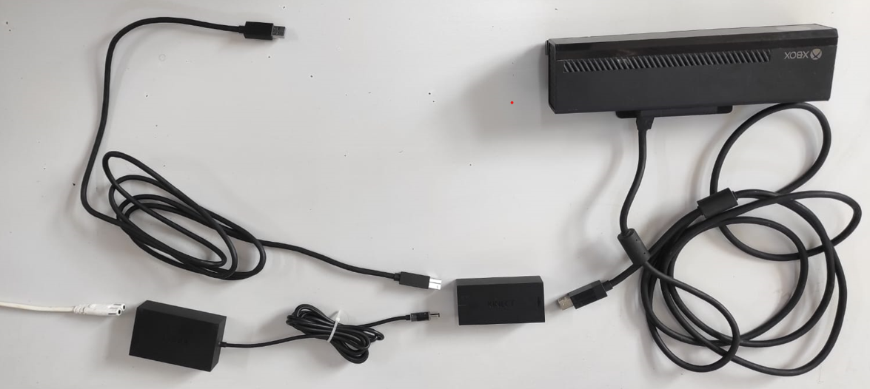 USB 3.0 🡪 PC/Raspberry Pi

Figure 4.1 Kinect Interconnection

**Kinect for Windows SDK Installation:** The Kinect for Windows SDK and necessary drivers were installed on the PC to facilitate the connection with the Kinect sensor. This setup enabled the capture and processing of motion data for model training.

**Step 2: Transitioning from PC to Raspberry Pi**

**Preparing Raspberry Pi with Windows 10 IoT:** The Raspberry Pi was set up with Windows 10 IoT Core, optimized for the system's requirements. The operating system was chosen for its compatibility with the Kinect sensor and its ability to handle the computational needs of the system.

**Optimizing TensorFlow Model for Raspberry Pi:** The trained TensorFlow model was transferred from the PC to the Raspberry Pi. This process involved not only moving the model files but also ensuring they were optimized for performance on the Raspberry Pi's hardware.

**Step 3: Setting Up Nao Robot and Establishing Connectivity**

**Installing Choregraphe on PC:** Choregraphe software was installed for programming and controlling the Nao robot. This software provided a user-friendly interface for creating robot behaviors and ensuring seamless interaction with the system.

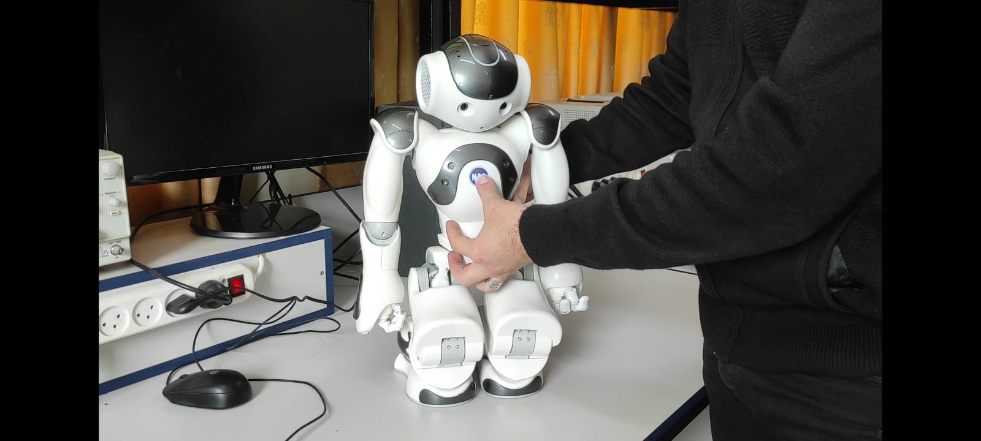**Establishing Wi-Fi Connectivity with Nao Robot:** The Raspberry Pi was configured to connect with the Nao robot via Wi-Fi. This wireless setup facilitated real-time control and data exchange, crucial for the system's responsiveness and functionality. To get IP from Nao, hold the button as on the image below:

Figure 4.2 How to get Nao’s IP

**Testing Wi-Fi Connection and System Integration:** The Wi-Fi connection between the Raspberry Pi and the Nao robot was thoroughly tested for stability and performance. The entire system's integration was evaluated to ensure cohesive operation between the Kinect sensor, Raspberry Pi, and Nao robot.

In conclusion, the hardware setup process involved a strategic combination of simulation and model training using Webots and TensorFlow on a PC, configuring the Raspberry Pi with Windows 10 IoT, and establishing a Wi-Fi connection with the Nao robot. This careful assembly and setup of the components laid the groundwork for the successful functioning of the system, paving the way for the effective implementation of the project objectives.

## 4.3 Software Configuration

The software configuration phase was pivotal in the system's implementation, ensuring seamless integration and functionality of all software components. This phase encompassed the installation and setup of various tools, libraries, and frameworks on the Raspberry Pi and the PC.

### 4.3.1 Installing Necessary Software

**Operating System Setup:** The Raspberry Pi was configured with Windows 10 IoT Core, chosen for its compatibility with the hardware components and suitability for the system's requirements. The PC was configured with Windows 10 Pro, providing a robust and reliable platform to support the development and simulation environment.

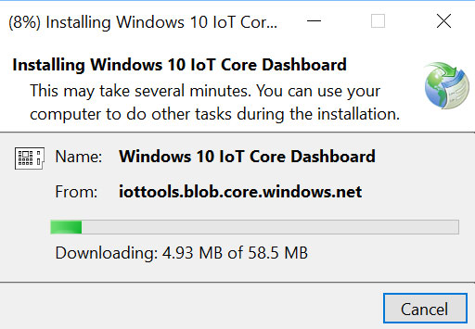

Figure 4.3 Windows 10 Iot Installation

**TensorFlow Installation:** Essential for machine learning tasks, TensorFlow was installed on both the Raspberry Pi and the PC to handle deep learning models and process data from the Kinect sensor.

**Webots Installation:** Webots robotics simulation software was installed on the PC to facilitate a virtual testing environment, crucial for developing and refining the model without constant physical testing.

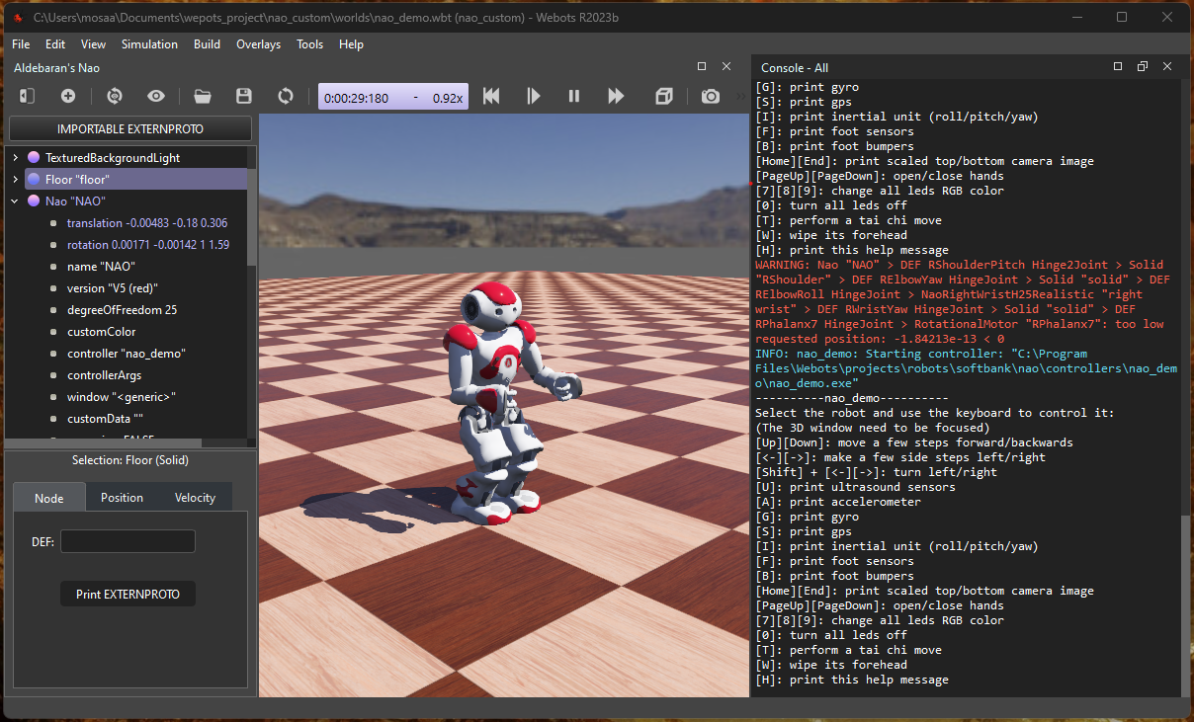

Figure 4.4 Webots Testing

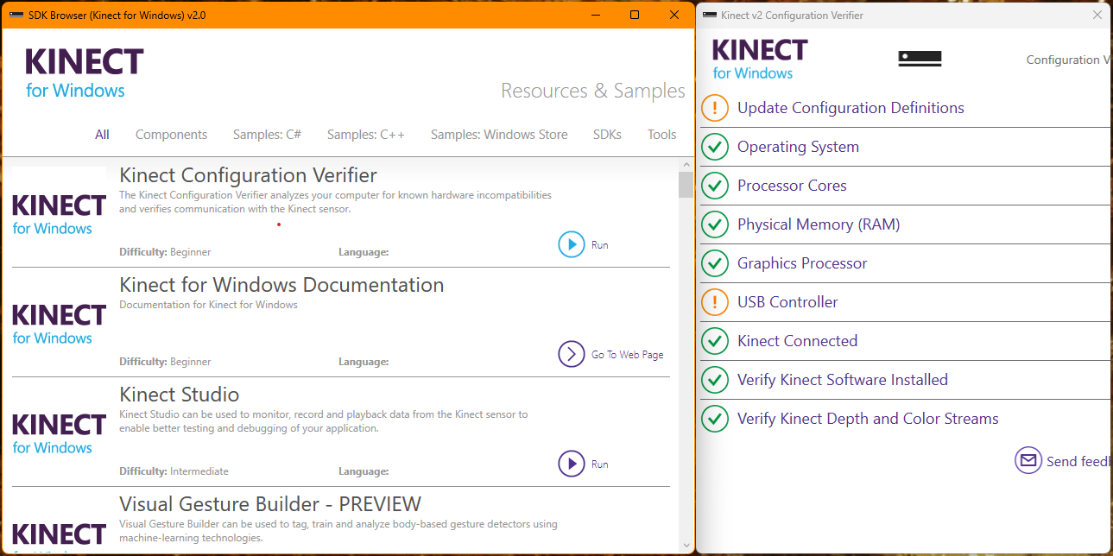**Kinect Software Setup:** The Kinect for Windows SDK and necessary drivers were installed on the PC, enabling proper communication and data capture from the Kinect v2 sensor.

Figure 4.5 Kinect Setup

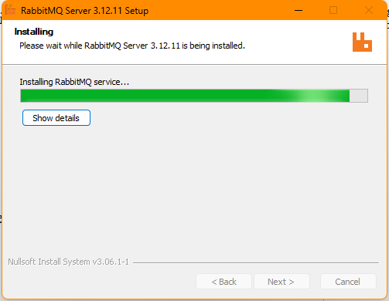**Rabbit MQ Installation:** Rabbit MQ was installed to facilitate data transfer from the Kinect to the Raspberry Pi. This message broker was essential for reliable and efficient communication within the system.

Figure 4.6 RabbitMQ Installation

### 4.3.2 Setting Up the Development Environment

**Configuring Nao with Webots:** Nao was set up in the Webots platform to simulate its movements and interactions. This step was crucial for testing and validating the inverse kinematics models and the overall system behavior.

**Installing Python 2.7 and C# with Required Libraries:**

* **Python 2.7 Installation and Library Setup:** Python was installed as a primary programming language for the system due to its versatility and support for a wide range of libraries. The installation included several specific libraries to enhance its functionality:
  + **Pika:** Pika, a RabbitMQ client library, was installed to provide an interface for Python applications to connect and interact with RabbitMQ, enabling efficient message queuing and dispatch.
  + **Pandas (as pd):** Pandas, a powerful data analysis and manipulation library, was incorporated for handling and processing structured data. It was imported as 'pd' for ease of use and readability in the code.
  + **NumPy:** This library was used for its extensive support for large, multi-dimensional arrays and matrices, along with a collection of mathematical functions to operate on these arrays.
  + **Math:** is a standard library module that provides mathematical functions and operations. It includes a variety of functions for basic arithmetic operations, as well as more advanced mathematical functions. We need from library trigonometric functions to implement inverse kinematics.
  + **TensorFlow Agents (Tf agent):** A specialized TensorFlow library for reinforcement learning, TensorFlow Agents was included to implement and run the Deep Deterministic Policy Gradient (DDPG) algorithm, crucial for training the system in replicating human movements.
* **C# Installation for Kinect Data Capture:** C# was installed to handle the Kinect data capture. C# is well-suited for interacting with the Kinect SDK and efficiently processing the sensor data. The choice of C# for this task was based on its robustness and seamless integration with the Kinect for Windows SDK, ensuring reliable and real-time capture of movement data from the Kinect sensor.

### 4.3.3 System Software Interconnection Implementation

#### 4.3.3.1 Read Body Tracking Data (C#)

* 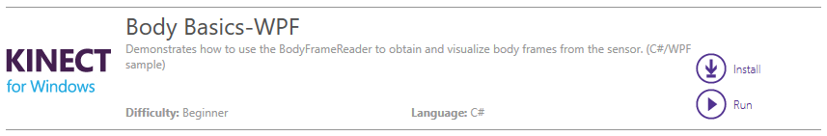Kinect for windows SDK provides C# code to read Body Tracking data. We can install it as **.sln** project and debugging it in Visual Studio.

Figure 4.7 Body Basics-WPF

* To deal with Kinect v2, we should import Microsoft.Kinect.
* The code performs 3 main missions:

1. Initialize Kinect

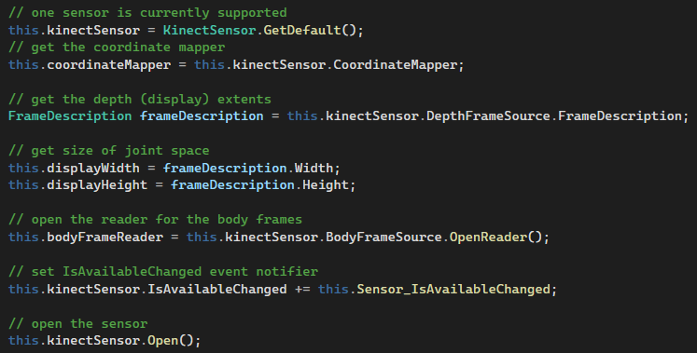

2. Declare bones list

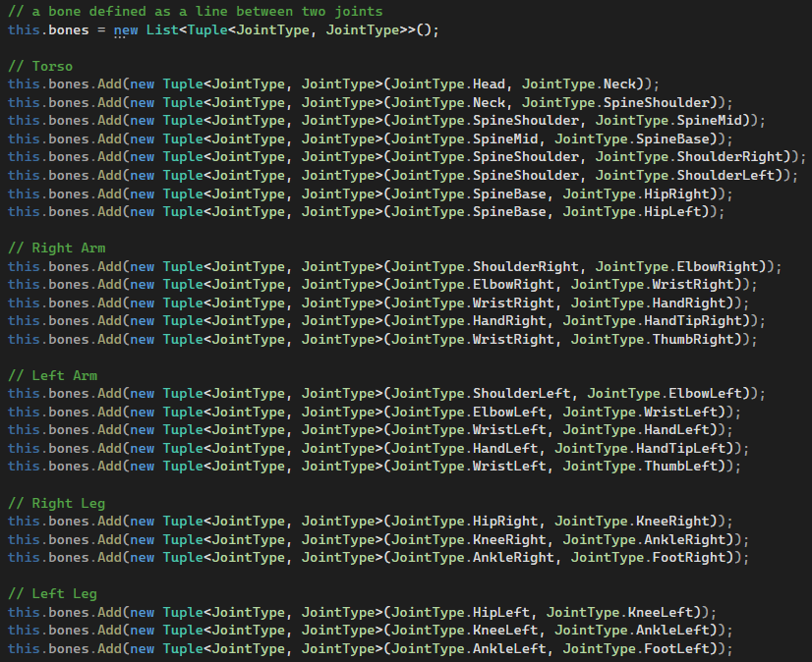

3. Read skeleton data (frame by frame)



#### 4.3.3.2 Move Body Tracking Data (Rabbit MQ)

**Send:**

* Body tracking data sent from C# Body Basics project to python.
* Required library: RabbitMQ.Client

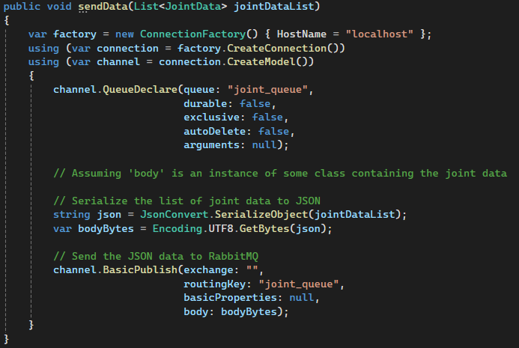

**Receive:**

* Body tracking data received form C# to python environment
* Required library: pika

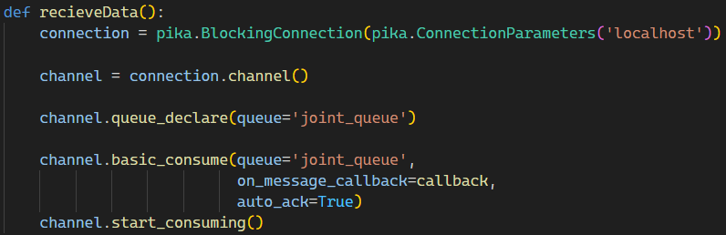

#### 4.3.3.3 Set Nao Angles

As we will explain later, Nao angles will be set based on Inverse Kinematics from Kinect body tracking data or DDPG trained model. The set position python code is the same for both algorithms:

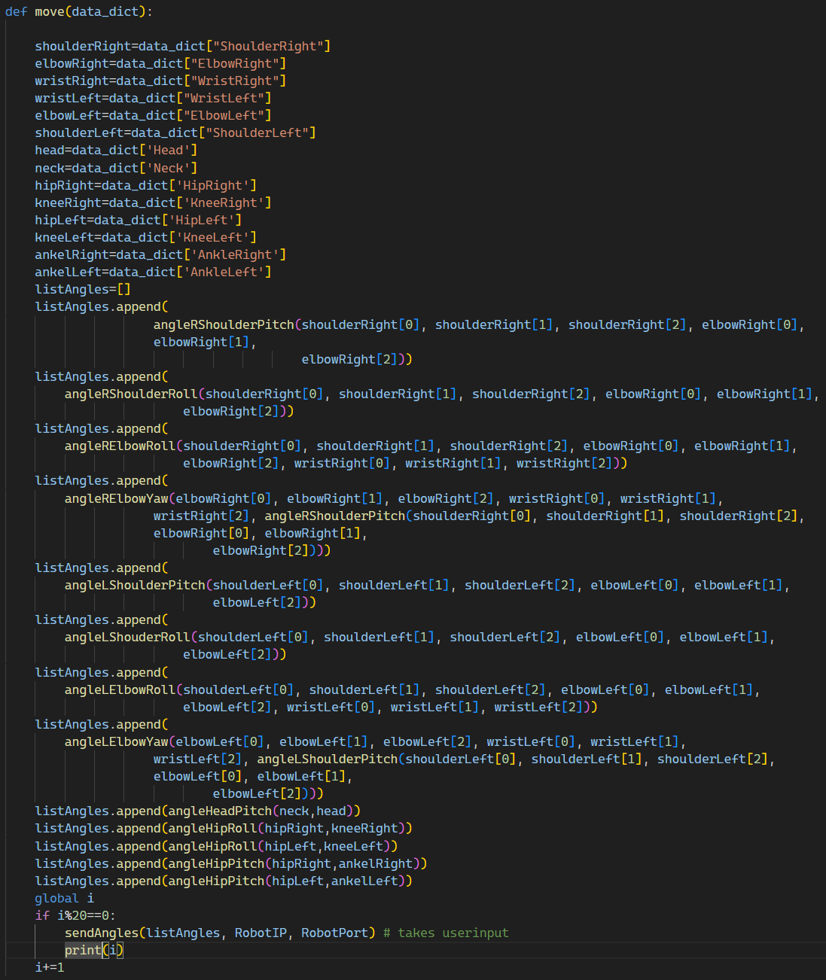

### 4.3.4 Inverse kinematics Implementation

Equations for Nao joints (θ) and Kinect Skeleton (sides of a triangle) were developed and integrated into the system. This involved creating mathematical models and algorithms to accurately translate human movements captured by Kinect into robotic movements.

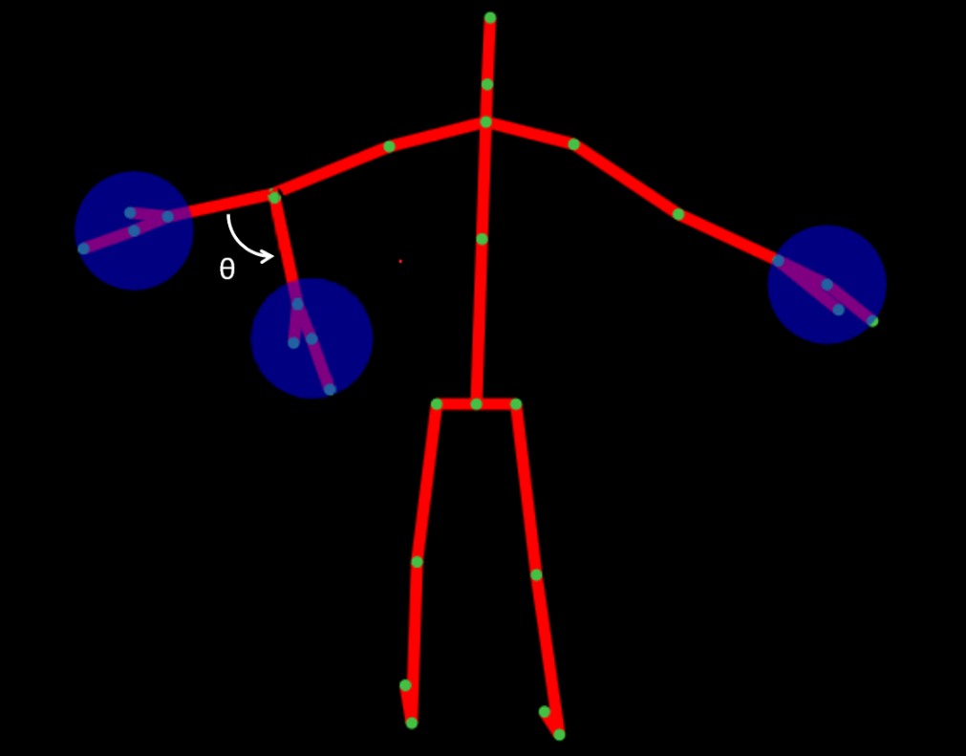

Figure 4.8 Kinect Skeleton

1. Equations

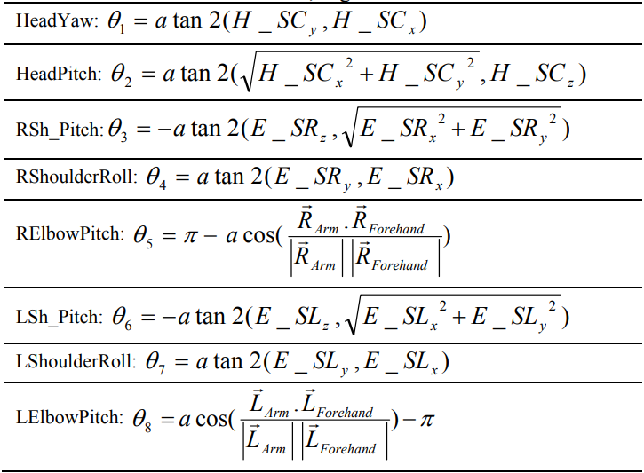

Table 4.1 Equations

2. Code

* HeadPitch

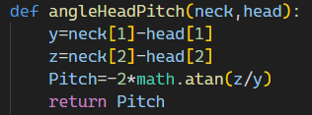

* SholderPitch

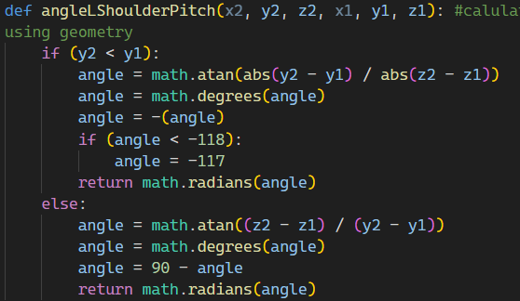

* SholderRoll

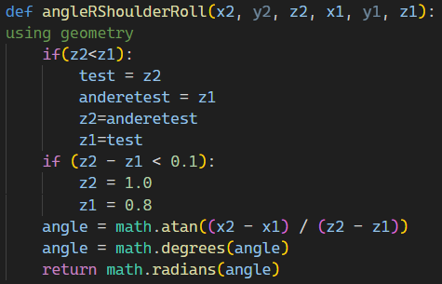

* ElbowYaw

+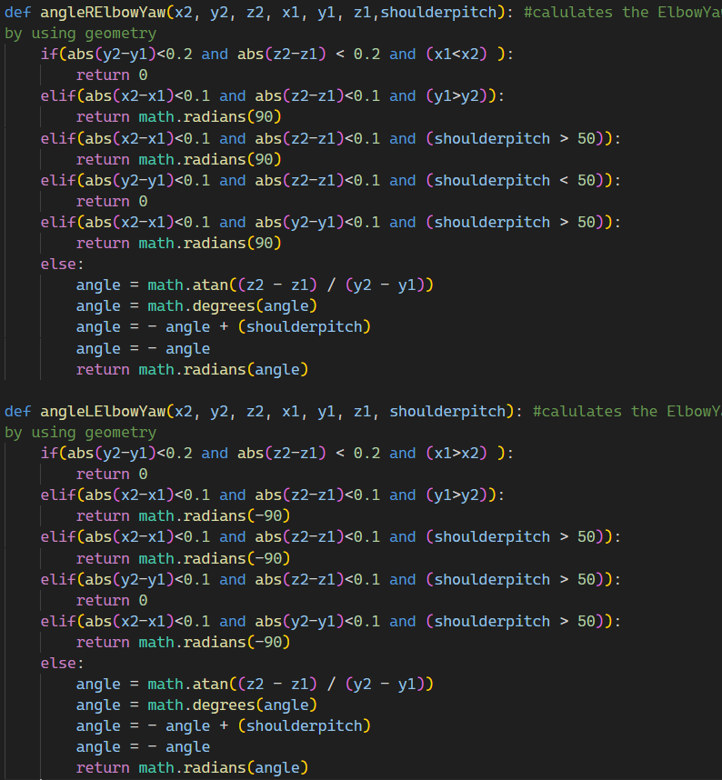

* ElbowRoll

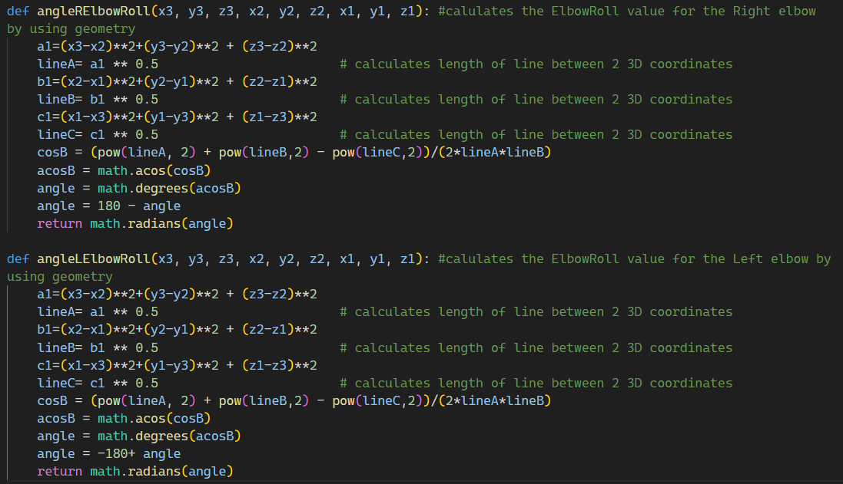

* HipRoll and HipPitch

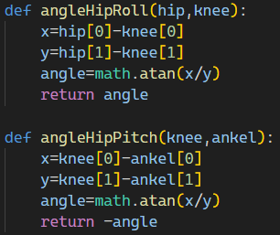

### 4.3.5 Model Training Implementation

#### 4.3.5.1 Description

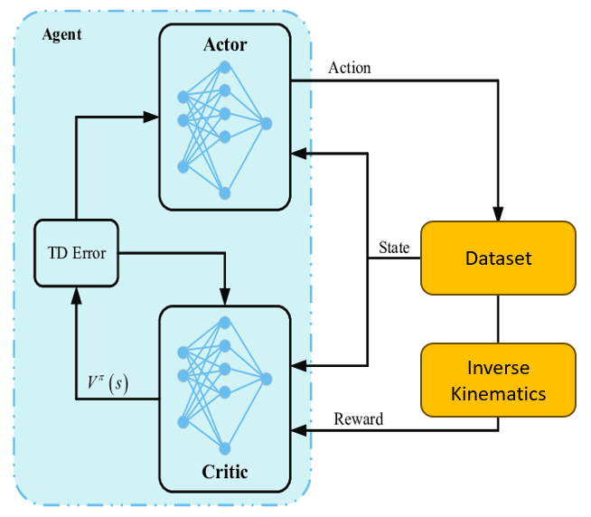In our training approach, we have selected inverse kinematics to serve as the reward function within the DDPG algorithm. The dataset itself forms the environment for the learning process. Initially, the agent critic commences with a zero reward and undergoes updates grounded in the imitation of inverse kinematics. As training progresses, the agent learns to optimize its actions based on the provided inverse kinematics rewards, effectively refining its performance in the given environment.

Figure 4.9 Training Approach

#### 4.3.5.2 Kinect v2 Dataset Selection for Training

For training our system, we selected the "3D Kinect Total Body Database for Back Stretches,"[28] a specialized dataset captured using the Kinect V2 sensor. This dataset's specifications are particularly suited for our project requirements [28]:

* **Data Collection:** Captured as a set of X, Y, Z coordinates at 60 fps during six different yoga-inspired back stretches, providing a detailed representation of human back movements​​.
* **Dataset Composition:** Contains 541 files, each detailing position and velocity for 25 body joints, including the head, neck, spine, shoulders, hips, wrists, knees, and feet​​.
* **Standardization and Consistency:** The Kinect was positioned at a height of 2 ft and 3 in, with subjects 6.5 ft away from the camera, ensuring consistent data capture. Each participant completed 10 repetitions of each stretch, providing a rich set of repeated movement data​​.
* **Participant Demographics:** Data was collected from 9 adults aged 18-21, including 4 females and 5 males, offering a diverse range of motion data​​.
* **Pre-processing:** Velocity data was calculated using a discrete derivative equation, which was applied to all body parts and axes individually, enhancing the data's utility for motion analysis​​.

#### 4.3.5.3 DDPG Implementation

* Required libraries: tensorflow, tf_agents, math, pandas, numpy
* Procedures

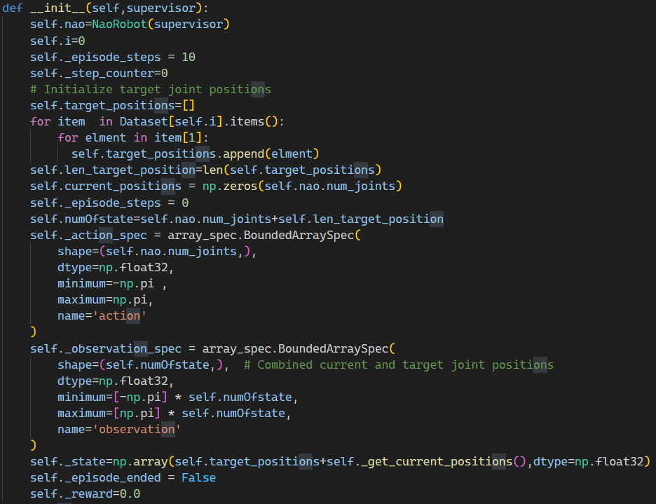1. Initial procedure

2. Reset Procedure

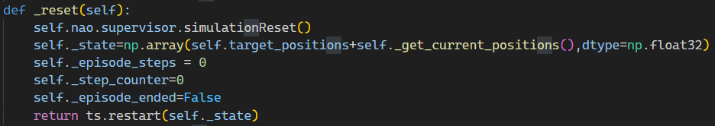

3. Update target position Procedure

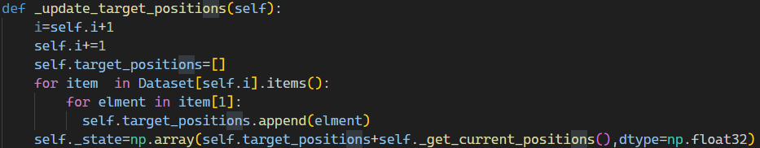

4. Step Procedure

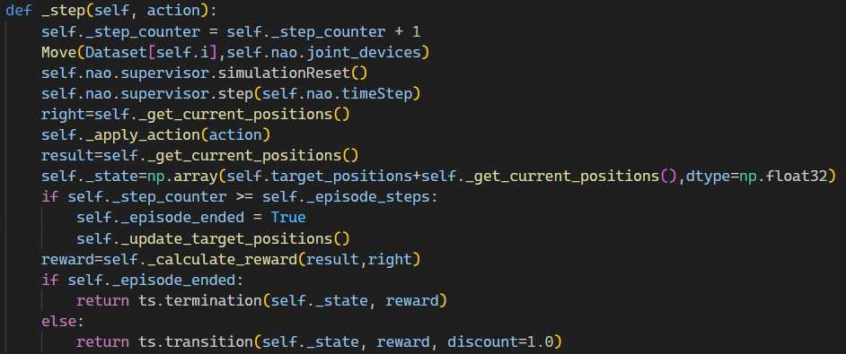

5. Calculate Reward Procedure

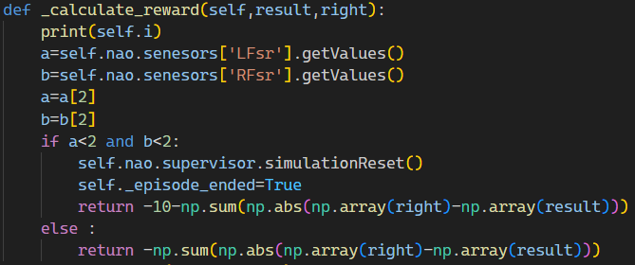

## 4.4 Challenges

The implementation of the system presented several significant challenges that needed to be addressed to ensure its successful operation. These challenges were critical in understanding the limitations and capabilities of the system and in guiding future improvements.

**1. Balancing**

**Challenge:** One of the primary challenges faced was maintaining the balance of the Nao robot while replicating human movements. Unlike humans, who have a highly developed sense of balance, robots like Nao require complex algorithms to remain stable, especially when performing dynamic movements or standing on one leg.

**Approach:** To address this, we had to fine-tune the control algorithms that manage the robot's center of gravity and joint movements. This involved iterative testing and adjustments to the robot's posture control system to achieve a balance that closely mimics human stability.

**2. Degree of Freedom between Nao and Human**

**Challenge:** The discrepancy in the degree of freedom (DoF) between humans and the Nao robot presented a significant challenge. Humans have a vast range of motion compared to the Nao robot, which has limited DoF in its joints.

**Approach:** To overcome this, we developed algorithms that could translate the complex human movements into simpler motions that the Nao robot could perform. This translation process involved determining the most critical aspects of the human movement and simplifying them to fit the robot's capabilities without losing the essence of the action.

**3. Training on PC, Not in Raspberry Pi**

**Challenge:** The computational limitations of the Raspberry Pi meant that it was not feasible to conduct the training of the deep learning models directly on it. Instead, the training had to be carried out on a more powerful PC.

**Approach:** The deep learning models were trained on a PC with sufficient computational resources to handle the intensive processing requirements. Once the models were trained and optimized, they were transferred and deployed on the Raspberry Pi for real-time operation. This approach ensured that the Raspberry Pi only needed to execute the pre-trained models, significantly reducing the computational load during actual system operation.

# Chapter 5: Testing and Results

## 5.1 Introduction

Chapter 5 is dedicated to the testing phase of the system, focusing on evaluating each hardware component and the overall interconnection within the system. This stage is crucial to ensure that all parts function correctly and cohesively.

## 5.2 Hardware Testing

* 1. Kinect v2

Testing the Kinect v2 involved verifying its ability to accurately capture motion data. This included assessing the sensor's responsiveness, precision in tracking movements, and consistency in different lighting conditions. Sometimes it appears some glitches in reading body data because the environment of SDK itself.

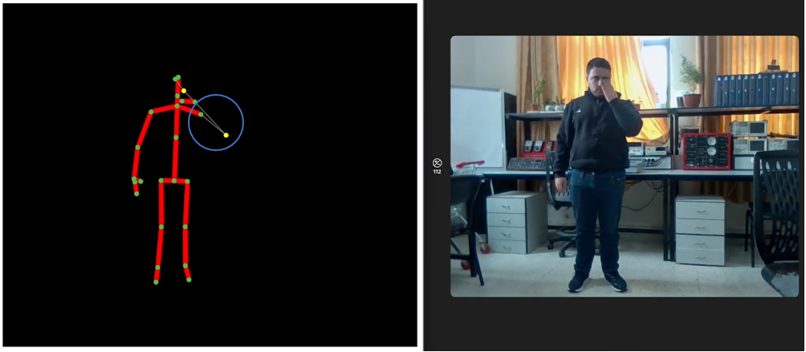

Figure 5.1 Kinect v2 glitch (example)

* 1. Nao Robot

Tests for the Nao robot focused on its movement replication accuracy, joint articulation, balance, and response time to commands received from the Raspberry Pi.

* 1. Raspberry Pi

The Raspberry Pi was tested for its computing performance, especially its ability to process and relay motion data to the Nao robot efficiently. Stability and reliability of the operating system and installed software were also evaluated.

* 1. System Interconnection

The final part of the testing phase involved evaluating the system's overall interconnection.

This included testing the communication flow between the Kinect v2, Raspberry Pi, and Nao robot, ensuring seamless data transfer and synchronization across the system.

## 5.3 Software Testing

* + 1. Inverse Kinematics

Testing of inverse kinematics involved validating the equations and algorithms used for translating human movement into robotic actions. This included simulations to ensure the movements were accurately mirrored by the robot.

* + 1. DDPG Algorithm

In the testing phase for the DDPG algorithm, the focus was on evaluating its effectiveness in learning and decision-making within a simulated environment. The algorithm was rigorously tested for its ability to correctly interpret sensory data, make accurate predictions, and adapt its responses over time. This involved running a series of controlled trials in simulated scenarios, monitoring the algorithm's performance in terms of learning efficiency, response accuracy, and stability. But there were some limitations as we will explain in **Results.**

* + 1. Webots

Webots was tested for its simulation capabilities, ensuring accurate rendering and physics simulation of the robot's movements and environment interactions.

* + 1. 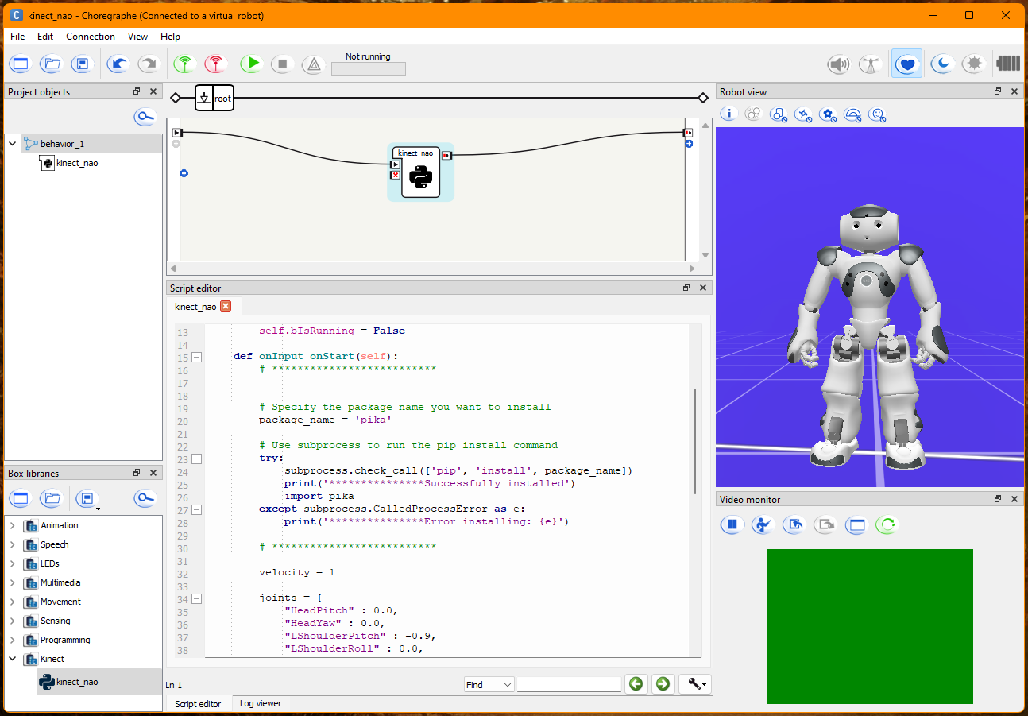Cherographe software was tested for its functionality in programming and controlling the Nao robot. We used Cherographe to test the final software (inverse kinematics and trained model), because it simulates the real environment of Nao. This included validating the user interface, motion creation tools, and the ability to upload scripts to the robot.

Figure 5.2 Cherographe Testing

* + 1. C# and Python Libraries

Libraries in C# and Python were tested for their roles in data capture and processing. For C#, the focus was on Kinect data acquisition, while for Python, the emphasis was on data analysis, machine learning tasks, and communication with other system components.

## 5.4 Results

### 5.4.1 Model training

The incorporation of machine learning, alongside our implementation of the Inverse Kinematics approach, aims to achieve two primary goals: ensuring effective balancing and addressing challenges related to degrees of freedom.

However, our utilization of the DDPG algorithm has encountered difficulties, which we attribute to the virtual environment's complexity. Specifically, the constraints imposed by the intricate virtual setting hinder our ability to apply model training with extensive datasets. This limitation is a key factor contributing to the DDPG algorithm's suboptimal performance in our computational context.

### 5.4.2 Inverse Kinematics

We have achieved favorable outcomes in Inverse Kinematics, enabling real-time and precise imitation of human head, arms, and legs movements:

Response time: 200 – 500 milliseconds

Accuracy: in terms of centimeters

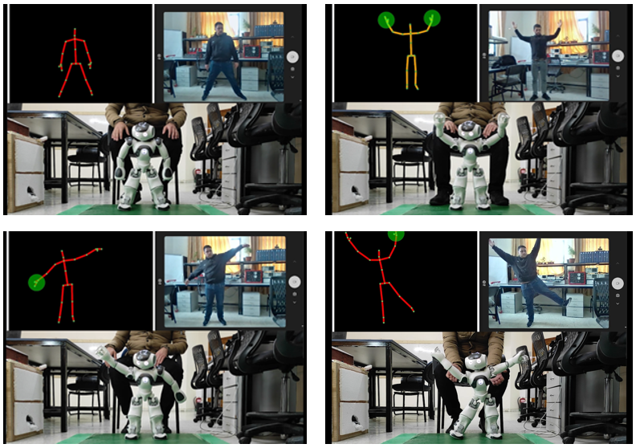There are some test form results:

Figure 5.3 Project Testing

# Chapter 6: Conclusion and future work

## 6.1 Conclusion

This project successfully developed and implemented a system integrating a Nao 6 robot, Kinect v2 sensor, and Raspberry Pi to mimic human movements. The hardware components, including the Kinect v2 sensor, Nao robot, and Raspberry Pi, were meticulously assembled and rigorously tested to ensure optimal performance and synchronization. In the software domain, key components such as inverse kinematics, the DDPG algorithm, Webots simulation, Cherographe programming, and various C# and Python libraries were methodically tested and refined.

The system's ability to accurately replicate human movements showcases the potential of robotics in various applications. The successful integration of the hardware and software components, alongside the effective implementation of deep learning algorithms, demonstrates the feasibility and effectiveness of such complex robotic systems.

## 6.2 Future Work

Looking forward, there are several avenues for future development and enhancement:

**Advanced Learning Algorithms:** Exploring more sophisticated machine learning algorithms could further improve the system's accuracy and efficiency in mimicking human movements. **Enhanced Hardware Capabilities:** Upgrading the hardware components, such as using a more advanced version of the Nao robot or a more powerful Raspberry Pi model, could offer better performance and enable more complex tasks.

**Broader Movement Repertoire:** Expanding the system to replicate a wider range of human movements, including more nuanced and subtle gestures, would increase its applicability.

**Real-World Applications:** Applying the system in real-world scenarios, such as in rehabilitation therapy or educational settings, would provide valuable insights into its practical utility and areas for improvement.

**User Interaction and Feedback:** Integrating user feedback mechanisms could make the system more interactive and user-friendly, adapting to individual users' needs and preferences.

In conclusion, this project represents a significant step in the field of robotics and human-robot interaction. The lessons learned and the foundation established here pave the way for further innovations and applications in this exciting and rapidly evolving field.

# References

1. Assad-Uz-Zaman, M., Islam, M., Rahman, M., Wang, Y. & McGonigle, E. (2021). Kinect Controlled NAO Robot for Telerehabilitation. *Journal of Intelligent Systems*, *30*(1), 224-239. <https://doi.org/10.1515/jisys-2019-0126>
2. Zhang, Y., Liu, Y., & Wang, J. (2019). Dynamic-goal Deep Reinforcement Learning for Industrial Robot Telemanipulation.
3. Chen, J., Wang, G., Hu, X. et al. Lower-body control of humanoid robot NAO via Kinect. Multimed Tools Appl 77, 10883–10898 (2018). [https://doi.org/10.1007/s11042-017-5332-3](https://doi.org/10.1007/s11042-017-5332-3%20)
4. Assad Uz Zaman, M., Islam, M.R., Rahman, M.H. et al. Robot sensor system for supervised rehabilitation with real-time feedback. Multimed Tools Appl 79, 26643–26660 (2020). <https://doi.org/10.1007/s11042-020-09266-x>
5. Balmik, A., Paikaray, A., Jha, M., & Nandy, A. (2022). Motion recognition using deep convolutional neural network for Kinect-based NAO teleoperation. Robotica, 40(9), 3233-3253. <https://www.cambridge.org/core/journals/robotica/article/abs/motion-recognition-using-deep-convolutional-neural-network-for-kinectbased-nao-teleoperation/AA337EC3B6AE611A13765DF1D4D1ECA5>.
6. Balmik, A., Jha, M. & Nandy, A. NAO Robot Teleoperation with Human Motion Recognition. Arab J Sci Eng 47, 1137–1146 (2022). <https://doi.org/10.1007/s13369-021-06051-2>
7. Hansard, M., Lee, S., Choi, O., & Houraud, R. (2012). Time-of-flight cameras: Principles, methods and applications. Springer. Retrieved from

<https://books.google.ps/books?id=PiF4narL1Z0C>.

1. Cruz-Ramírez, S.R., García-Martínez, M. & Olais-Govea, J.M. NAO robots as context to teach numerical methods. Int J Interact Des Manuf 16, 1337–1356 (2022). <https://doi.org/10.1007/s12008-022-01065-y>
2. Wikipedia, "TensorFlow," [Online]. Available: <https://en.wikipedia.org/wiki/TensorFlow>. [Accessed 2022].
3. Cyberbotics.(2023).Webots:RobotSimulator.Retrieved from <https://www.cyberbotics.com>.
4. MIT Sloan. (2021). Machine learning, explained. Retrieved from

<https://mitsloan.mit.edu/ideas-made-to-matter/machine-learning-explained>

1. Sewak, M. (2019). Introduction to Reinforcement Learning. In: Deep Reinforcement Learning. Springer, Singapore. <https://doi.org/10.1007/978-981-13-8285-7_1>
2. Towards Data Science. (2018). Training Deep Neural Networks. Retrieved from <https://towardsdatascience.com/training-deep-neural-networks-9fdb1964b964>.
3. Sumiea, E. H., AbdulKadir, S. J., Al-Selwi, S. M., Alqushaibi, A., Ragab, M. G., Fati, S. M., & Alhussian, H. S. (2023). Deep Deterministic Policy Gradient Algorithm: A Systematic Review.
4. Lillicrap, T. P., Hunt, J. J., Pritzel, A., Heess, N., Erez, T., Tassa, Y., Silver, D., & Wierstra, D. (2016). Continuous control with deep reinforcement learning. In Proceedings of the International Conference on Learning Representations (ICLR). Google DeepMind, London, UK.
5. Sutton, R. S., & Barto, A. G. (2005). [The actor-critic architecture.]. Reinforcement Learning: An Introduction Retrieved from

<http://incompleteideas.net/book/first/ebook/node66.html#fig:actor-critic.>

1. Vaughan, H. (2023). Develop your first AI agent - Deep Q Learning. Towards Data Science. Retrieved from <https://towardsdatascience.com/develop-your-first-ai-agent-deep-q-learning-375876ee2472.>
2. MathWorks. (2023) .DDPG Agents. Retrieved from

https://in.mathworks.com/help/reinforcement-learning/ug/ddpg-agents.html.

1. Aldebaran. (2022). NAO. Retrieved from <https://www.aldebaran.com/en/nao>.
2. Wevolver. (2023) . NAO Robot Specifications. Retrieved from

<https://www.wevolver.com/specs/nao.robot>

1. Packt Publishing. (n.d.). Components of Kinect for Windows. In Kinect for Windows SDK Programming Guide. Retrieved from

<https://subscription.packtpub.com/book/programming/9781849692380/1/ch01lvl1sec08/components-of-kinect-for-windows>.

1. Soltaninejad, Sara & Cheng, Irene & Basu, A.. (2019). Kin-FOG: Automatic Simulated Freezing of Gait (FOG) Assessment System for Parkinson’s Disease. Sensors. 19. 2416.
2. Microsoft. (2022). Kinect for Windows. Retrieved from <https://learn.microsoft.com/en-us/windows/apps/design/devices/kinect-for-windows>.
3. Raspberry Pi. (n.d.). Raspberry Pi 4 Model B Specifications. Retrieved from <https://www.raspberrypi.com/products/raspberry-pi-4-model-b/specifications/>
4. Robot Advance. (2023). Raspberry Pi 4 Model B 4Go. Retrieved from <https://www.robot-advance.com/EN/art-raspberry-pi-4-model-b-4go-2640.htm>.
5. Raspberry Pi. (2022). Raspberry Pi Documentation. Retrieved from

<https://www.raspberrypi.com/documentation/computers/raspberry-pi.html>

1. Hua, J., Zeng, L., Li, G., & Ju, Z. (2021). Learning for a Robot: Deep Reinforcement Learning, Imitation Learning, Transfer Learning. Sensors, 21(4), 1278.

<https://doi.org/10.3390/s21041278>

1. Kaggle. (2020). 3D Kinect Total Body Database for Back Stretches. Retrieved from <https://www.kaggle.com/datasets/dasmehdixtr/3d-kinect-total-body-database-for-back-stretches?resource=download&fbclid=IwAR0JeW4wkyeMfBQbXyVOe8Cl4eWXns4NMwmmjtHxuASBFOjKQ9p8DdxUFwQ>.
2. Xing, QJ., Shen, YY., Cao, R. et al. Functional movement screen dataset collected with two Azure Kinect depth sensors. Sci Data 9, 104 (2022). <https://doi.org/10.1038/s41597-022-01188-7>
3. Ahamed, K. I., & Akthar, S. (2016). A Study on Neural Network Architectures. Computer Engineering and Intelligent Systems, 7(9). Retrieved from

<http://www.iiste.org/Journals/index.php/CEIS/article/view/32856>.

1. Giang, H., Hoan, T., Thanh, P., & Koo, I. (2020). Hybrid NOMA/OMA-Based Dynamic Power Allocation Scheme Using Deep Reinforcement Learning in 5G Networks. Applied Sciences, 10(4236). <https://doi.org/10.3390/app10124236>.